Module 9. Handout 1

 | Topics for creating Discussion questions
1.  2.  3.  4.  5.  6.  7.  8.  9.  10. | Modern technology  Studying abroad  Holidays  Social media applications  Sports

Module 9. Handout 2. Mock Debate - Graphic Organizer

Topic: Should schools require students to wear uniforms?

Team A | Team B
Opening Statement (Claim) | Opening Statement (Claim)
Reasons/Evidence | Counterclaim  Reasons/Evidence
Counterclaim/Refutation  Closing Statement | Closing Statement

Module 9. Handout 2. Mock Debate - Graphic Organizer

Topic: Should schools require students to wear uniforms?

SAMPLE

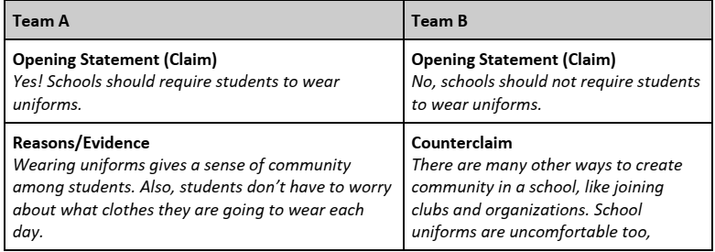
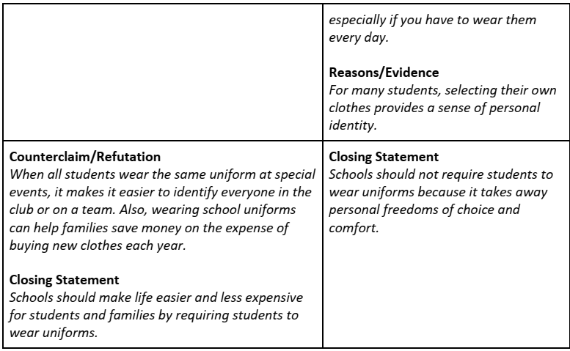

Module 9. Handout 3. Jigsaw Reading

Articles | Key points from the articles
Navigating Discussions and Debates in the EFL Classroom
Critiquing Questions
Bring it On: How to Get Students Fired Up about English with ESL Debates

Module 9. Handout 4. Lesson Plan

Activity/Lesson Name:

Grade level / Unit:

Activity Description:

- The purpose of this activity is to…

- This activity will be effective for this lesson/unit because…

- Here are some steps to help you use this activity in your classroom…

Step 1:

Step 2:

Step 3:

