Workshop Training Plan Template

Workshop Title: Module 2: Giving Clear Instructions
Workshop Description: _ Too often, students are unable to effectively participate in learning activities in the language classrooms, not because they do not understand the content but because teachers do not provide clear instructions. Through this module, you will explore the challenges, purposes, and ways of giving clear instruction in your English classrooms. You will learn how to give clear instructions using English and engage students to participate in communicative learning tasks.

Nine Events | Description of Instructional Event | PowerPoint Slides or Handouts
1. Gain attention  15-20 minutes | Warm-up : Picture prompt. Teacher puts the picture of a waterfall on the screen and participants should make a story based on what they see.  Gain their attention with a quote: “Good directors give short and specific instructions to their actors” (Bill Hader)  Elicit participant responses about what the quote means. (to ensure that they fully comprehend what they need to do to achieve in i their classrooms) | 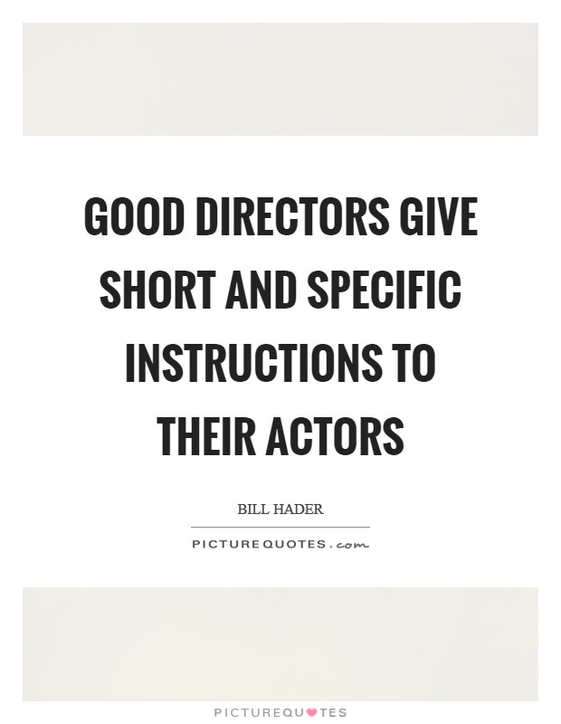
2. Inform learners of objectives  5 minutes | Read through the objective (on PPT slide)  - describe the features of good teacher talk  - use several modeling strategies  - write and practice speaking effective teacher talk for your lessons  - reflect on how to prepare a teacher talk and share a sample teacher talk using an activity  - understand clear instruction is very important, understand step-by-step instruction is mandatory | PPT slide  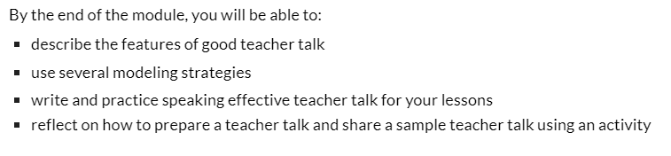
3. Stimulate recall of prior learning  30 minutes | To start, divide the class in half and demonstrate to participants that they should form two concentric circles.  - Each participant in the outside circle should face a student in the inside circle, thus forming a pair. Give each participant in the outside circle a fluency circle strip that you have prepared in advance. (If you have an odd number of participants, one participant can wait on the outside for one round. At the end of that round, that participant enters the outside circle and another participant comes out for one round, etc.)  - When you tell them to start, the participants in the outside circle begin the task by asking the questions on their fluency circle strip one by one.  - The participants in the inside circle respond and the pairs continue to talk until you tell them to stop.  - When everyone has stopped talking, ask the participants in the outside circle to rotate one place, repeat the process and rotate again. After they have spoken with three partners, ask them to rotate again, switch roles, and begin again. Generally the participants in the outside circle will rotate three times and then the participants on the inside circle will rotate three times. However, if the content is difficult for your participants, you can ask them to continue for several more rounds.  - Summarize the participants’ opinions on benefits of giving clear instructions. | Question:  What are the instructions? When do we need them?  How do you give clear instructions to your learners?
4. Present the content  15-20 minutes | Demonstrate the videos from TETE:  Video 1. Giving Clear Instructions for Forming Groups. After watching Video 1 check the participants understanding through Thumbs up/Thumbs down activity  Video 2. Teacher Talk for Managing Activities  After watching Video 2 check the participants understanding through True/False corner activity | https://sites.google.com/view/mason-tete/module-2-giving-clear-instructions#h.d9s5x4joqznj) 👍/👎  https://sites.google.com/view/mason-tete/module-2-giving-clear-instructions#h.jlrkb18alur1  ✅ ❎
5. Guide learning  30-40 minutes | Reading the Article 1: Common Mistakes in Teacher Talk by Hyunsun Chung and Woomee Kim  Reading the Article 2: Giving Effective Instructions: Using Think Aloud by Hyunsun Chung and Woomee Kim  Article 3: The Movable Class: How to Class-Manage for More Active and Healthful Lessons by Kevin McCaughey  Gallery walk (A “Gallery Walk” is an activity that allows participants/students to discuss and display their final work around a room much like artists would display their artistic pieces in an “exhibit.” It is a way that participants/students can share their group work projects or individual literary responses to a text in a non-threatening way with the assurance of getting some feedback from their learning community) | https://www.readingrockets.org/article/using-think-alouds-improve-Reading-comprehension
6. Elicit performance (practice)  20 minutes | Using your cellphone or another camera, create a short video (less than 90 seconds) of you giving effective instructions in English to your students. You don’t need to have real students in front of you for this video, you can say a set of instructions that fit your teaching context. To create this video, you can consider the following:  - Write a monologue of clear instructions that you say to your students.  - Write a dialogue with a teacher and students, with the teacher giving clear instructions and students responding to the teacher.  - In your video, you can role play on your own or ask another person to record with you. You do not need to have actual students in the video.  - You may use expressions that are presented in this module and/or other expressions that you need to use in your teaching.  - Practice saying your script as needed, before recording your video.
7. Provide feedback  15 minutes | Gets and needs - In order to organize “Gets and Needs” feedback strategy ,participants need to draw a line in the middle of the paper and make a list of Gets-the information he/she got , understood and wants to apply in his teaching. Another column is Needs- the information participant did not fully understand or some points which were not clear for him/her.  The instructor then collects the papers in order to clarify what went well and what should be retaught. | 
8. Assess performance  20 minutes | - Create an infographics about giving clear instructions.  - Participants create infographics on the poster or on canva and should send them via email.
9. Enhance retention and transfer  20 minutes | Before leaving the workshop ask participants which activity they liked and want to implement in their lessons. | 

