Workshop Title: Module 3 EFFECTIVE QUESTIONS AND ANSWER

Nine Events | Description of Instructional Event | Power Point Slides or Handouts
- Gain attention  3 minutes | Display the PPT slide and introduce the topic of the session.
- Inform learners of objectives  5 minutes | By the end of the module, participants will be able to:  - understand how different types of questions are used in teacher talk  - form beginner friendly questions  - scaffold students’ response in more comfortable and effective ways  - practice basic question forms and answers with students
- Stimulate recall of prior learning  Response cards  10 minutes  15 minutes | - Make copies of Response Cards for each participant  - Make 1 large copy or PPT slide of the three statements  - Discuss the directions for the activity.  1. When I read a true statement, raise your handout to say “True.”  2. When I read a false statement, turn your handout over to say “False.”  Model the activity with these statements.  3.Show and read each statement one at a time:  Ask participants how they engage their students to participate in the lesson. How they make their students share their thoughts.  Participants share their experience about how they engage and make students communicate by using English.  Tell the participants to discuss the questions with elbow partners:  - What is the role of asking questions in the classroom?  - What part of the activity do you usually ask questions - in the beginning, when transitioning, or at the end of a lesson? Why is it your favorite?  - How helpful is asking questions in the class?
4. Present the content  Thumbs up/ down activity  15 minutes  15 minutes | The participants will explore the ideas for effective questions and answers in English by watching two videos.  Video 1. “Asking Questions during Listening Tasks”  Tell the participants that this video will introduce some techniques of asking effective questions in English in pre-while-post activities.  Link to YouTube: TETE - Asking Questions During Listening Tasks - YouTube  Video 2. “Practicing Wh-Questions using Information Gap Activities”  Tell the participants that this video will show you an example of how to lead your students to form and use basic wh-questions in classroom activities.  Link to YouTube: TETE - Practicing Wh Questions Using Information Gap Activities - YouTube
5. Guide learning  Think Pair and Share  30 minutes  Give One and Get One Information Gap Activity  20 minutes | Have participants read Article 1: Questions and Responses. Give them 7 minutes. After reading the article, ask them a question that they must first consider by themselves. After giving them time to think, have them discuss the question with their neighbor. Once they've discussed the question, invite participants to share their answers with others. By giving them this time to process, you enable them to be more engaged in their learning.  Article 2: Display Questions vs. Referential Questions by Hyunsun Chung
6. Elicit performance (practice)  20 minutes | Ask following questions:  - Do you use English when you ask questions in your classroom? If yes, what are some examples of the questions that you ask? If not, what are some challenges that prevent you from asking questions in English?  - When you ask them questions, do your students try to answer in English?  - What might help them to answer in English during the lesson?  Ask participants to choose a part (reading or listening) in their textbook and create a set of questions that fits for the learning goal of the part they’ve selected and think about a possible question and answer situation that might happen in that learning sequence. They are supposed to use the tasks and languages for different goals they have watched and read in the module such as an information gap activity.
7. Provide feedback  20 minutes | Participants work in groups and share their set of questions with their groupmates. After sharing ask them following questions:  - Which of the suggested ways of giving questions do you think can be adaptable to your teaching context? Why and why not?
8. Assess performance  10 minutes | Exit tickets  Participants complete exit tickets | 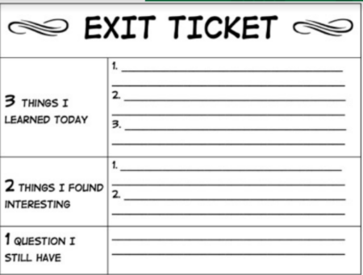
9. Enhance retention and transfer  15 minutes | Participants will use the self-check chart in the Article 2 to examine how the questions and responses were used in their lesson.

