Workshop Title: Module 5 Increasing classroom interaction

Nine Events | Description of Instructional Event | PowerPoint Slides or Handouts
1. Gain attention  10 minutes | A great wind blows Activity
2. Inform learners of objectives  5 minutes | By the end of the module, you will be able to:  - describe the importance of student-to-student interaction in a language classroom  - examine and use a variety of effective activities that promote meaningful interaction in a classroom  - share different communicative activities that are effective for English learners
3. Stimulate recall of prior learning  30 minutes | Concentric circle Activity
4. Present the content  40 minutes | Demonstrate the Video 1 Increasing Student-to-Student Interaction  Video 2: Find Someone Who Bingo  Video 3: Guiding the Artist
5. Guide learning  Create graphic organizer  20 minutes | Read Article  Scaffolding Part Two: Supporting Language Production
6. Elicit performance (practice)  40 minutes | Ask participants following question  Have you ever developed any useful activities (or strategies) of your own to give your students practice in spoken English? If yes, write some thoughts down about one activity (or strategy), and explain why it has been effective and useful in promoting interaction among your students.  Consider the following questions as you think about your interaction activity (or strategy):  - What stage of the lesson have you used this activity (or strategy) and why?  - How has this activity (or strategy) promoted meaningful communication?  - What visual aids did you use, if any, to make your activity (or strategy) more interesting and meaningful?  Create an activity (or strategy) that will generate communicative interactions among students. The purpose is to share one idea and receive many others that you can use in the classroom. This is an opportunity to learn new teaching ideas from each other and improve your practice. Use the template below when creating your activity.  Activity Name:  Activity Description:  - This activity is effective because…  - Here are some steps to help you use this activity in your classroom:  Step 1:  Step 2:  Step 3:
7. Provide feedback  10 minutes | KWL chart
8. Assess performance  10 minutes | Exit tickets  Participants complete exit tickets | 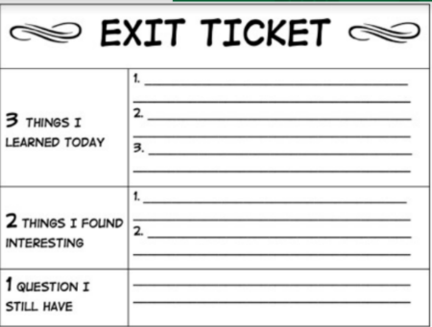
9. Enhance retention and transfer  15 minutes | After participants share an activity in the group, they think about other groups’ activities. They find at least one or two new activities that they can use in their next class. Ask them to apply a new activity from this module in their next class. If it is a success tell others why it was a success next week.

Video 1 https://sites.google.com/view/mason-tete/module-6-ptra-plan-teach-reflect-adjust#h.votnkjdaelte
Video 2 https://sites.google.com/view/mason-tete/module-6-ptra-plan-teach-reflect-adjust#h.vav5iq460ek1
Video 3 https://sites.google.com/view/mason-tete/module-6-ptra-plan-teach-reflect-adjust#h.h0sez7121s56

