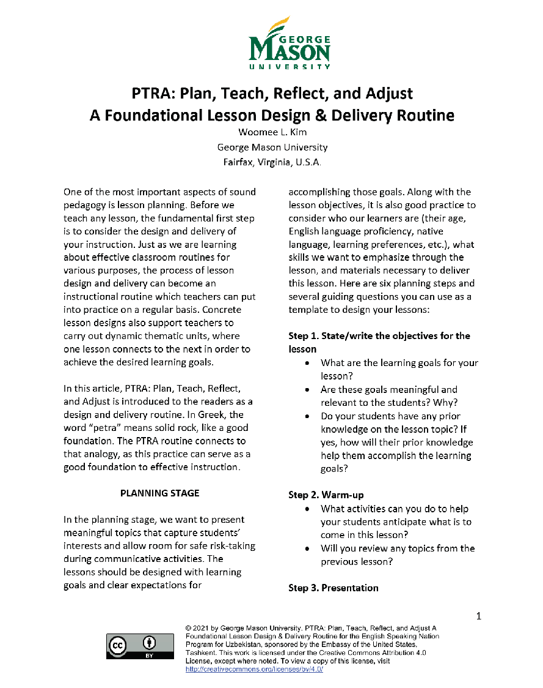

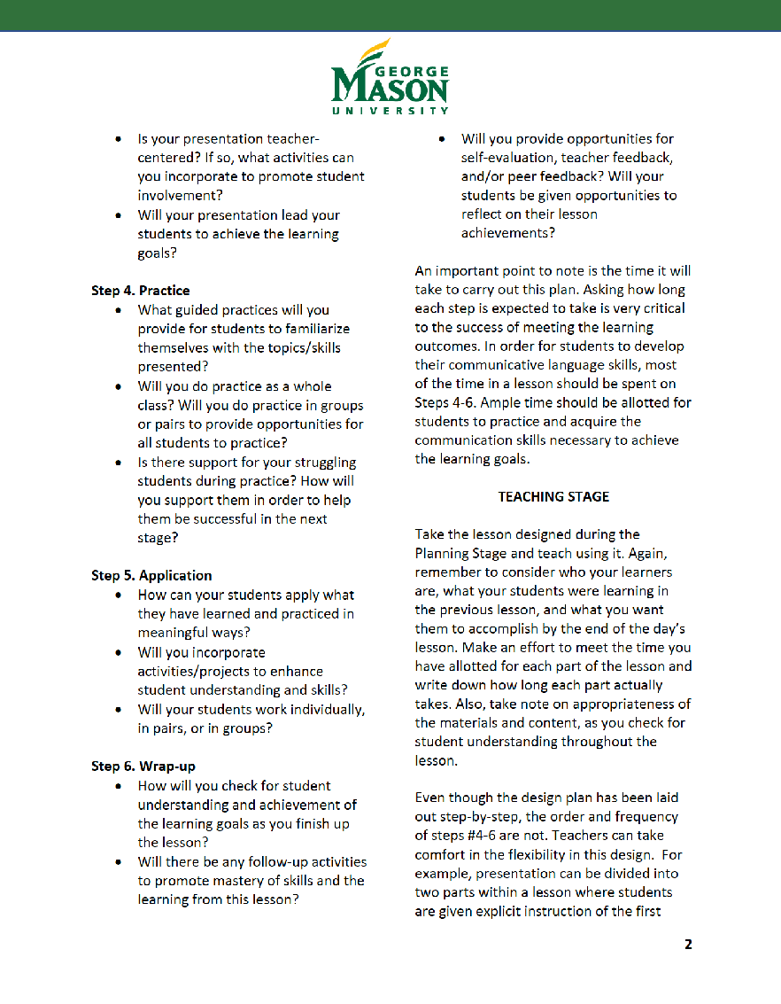

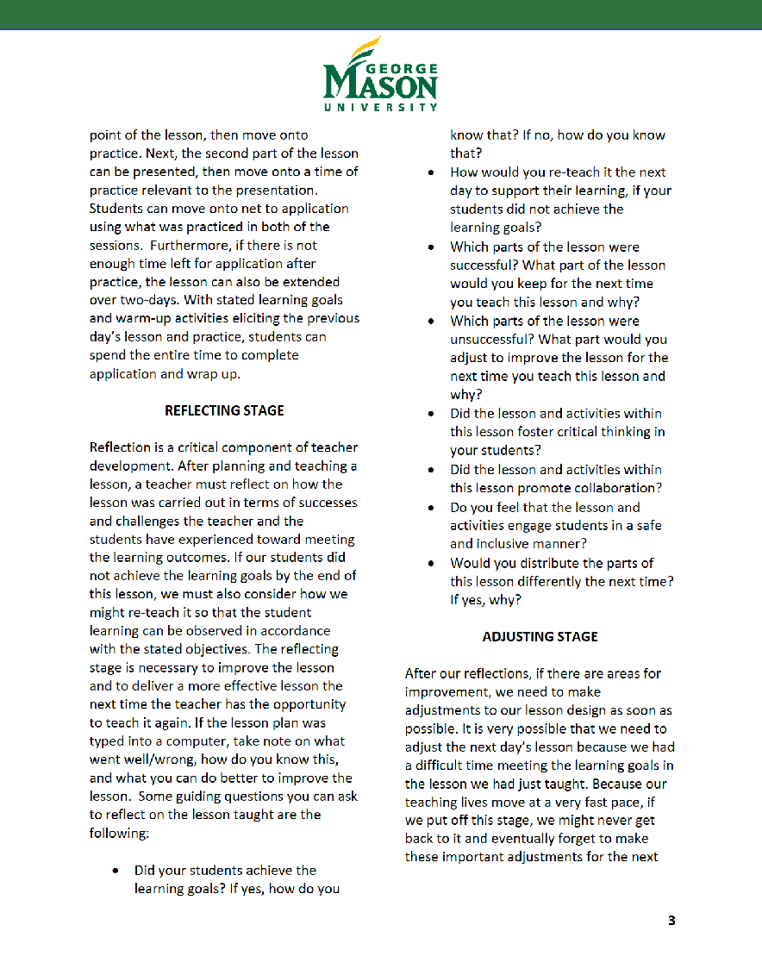

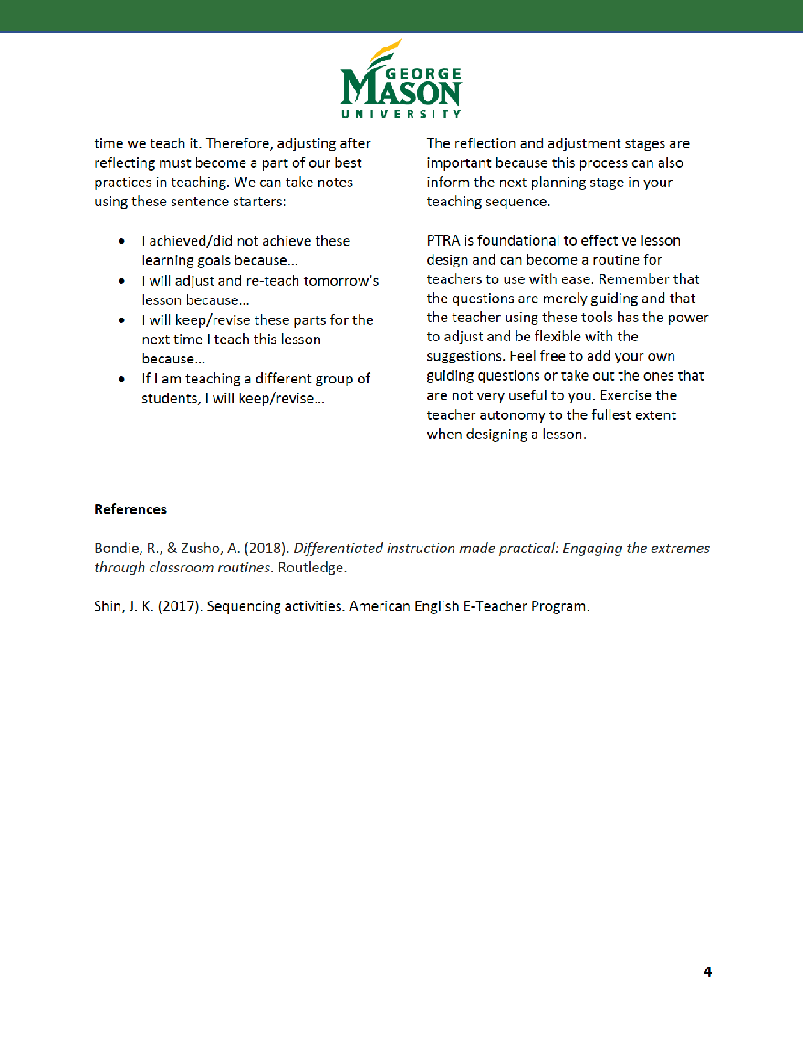

Module 6 Handout № 1

Cut the topic of the lesson and objectives separately. Mix the objectives and deliver them to each group. Each group should match the Lesson topic to its objectives. You can adjust the handout as much as you wish.

| Topic | Objectives |
| --- | --- |
| **What is the best transport?** | ·         *Students will be able to identify different modes of transportation and the vehicles used for each mode.*  ·         *Students will learn about the uniqueness and similarity of the different vehicles.* |
| **Are you a good conversation maker?** | ·        *By the end of the lesson, students will be able to lead conversation using opinion, agreement and disagreement conversational transitions in their speech.*  ·        *They will be better able to use vocabulary related to expressing opinion in meaningful and supportive dialogue.* |
| **Project ( Practice of regular verbs and the story of a young celebrity)** | ·        *By the end of the lesson, students will be able to speak about household activities in the Past Simple tense, pronouncing the correct spelling of “ed”.*  ·        *Describe a celebrity of a young age via making a poster.* |
| **What is work?** | ·         *By the end of the lesson, the students will be able to speak about work and its meaning.*  ·         *They will be able to differentiate the meaning of the words perks, salary and wages.*  ·        *They will be able to speak about job responsibilities and have a clear understanding of what a job is and its hardship and benefits.* |

Module 6  Handout № 2

Learning objectives begin with the phrase: “At the end of this lesson or activity, participants will be able to…” Moreover, you should choose your objectives deliberately relying on what your lesson or activity is going to deal with. For example, it can be facts, some with concepts and some with the application of the information. Assuming that the objectives are well written with the choice of necessary verbs to show progressive outcome of your lesson.

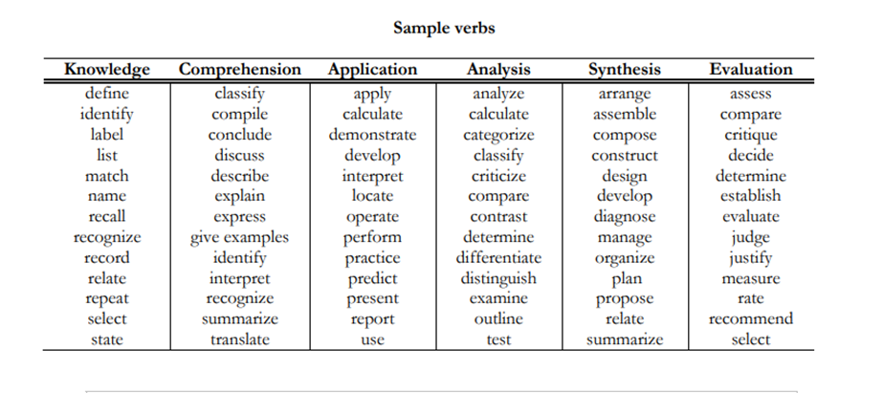

Module 6 Handout № 3

