Workshop Title: Module 6 PTRA- Plan, Teach, Reflect, Adjust

Nine Events | Description of Instructional Event | PowerPoint Slides or Handouts
1. Gain attention  10-15 minutes | Warm up: Activity I mustache  "There are three types of lessons: The one we plan to teach; the one we actually teach; and the one we wish we had taught." – Unknown  Ask participants` opinion about the quote.
2. Inform learners of objectives  5 minutes | By the end of the module, you will be able to:  - plan, teach, reflect, and adjust lesson plans to promote effective communicative language practice in their classrooms  - develop an effective lesson plan for English learners that teaches language through meaningful context and promotes communicative interaction using engaging activities  - design effective lesson plans for English learners using the following steps: warm up, presentation, practice, application, and wrap up
3. Stimulate recall of prior learning  10 minutes | Stimulate teachers beliefs in the significance of good objectives, sequencing activities and reflecting on teaching.
4. Present the content  25-30 minutes | Demonstrate the Video 1: Writing Good Objectives  After watching the video ask participants to complete the sentences  Video 2: Sequencing Activities  Video 3: Activating Your Reflective Teaching  Group Work; Choose a topic in the unit of any grades and create a lesson plan | Demonstrate it in Group.
5. Guide learning  Jigsaw Reading  30 minutes | Read Article 2: PTRA: Plan, Teach, Reflect, Adjust by Woomee Kim  Article 1: Developing Dynamic Units for EFL by Joan Kang Shin
6. Elicit performance (practice)  10-15 minutes | - What are some examples of communicative lesson plans you have used successfully in your teaching context? What is your favorite communicative lesson plan that you have taught? Explain why.  - If you do not use communicative lesson plans yet, what aspects would you like to improve, either from “PTRA” or “Six-Steps of Lesson Planning”?  - What are the challenges in creating communicative lesson plans for your learners?
7. Provide feedback  10 minutes | P  Q  p
8. Assess performance  10 minutes | Exit tickets  Participants complete exit tickets | 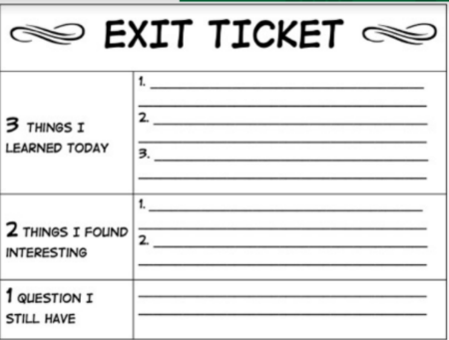
9. Enhance retention and transfer  15-20 minutes | Ask participants to think of a lesson they would like to teach and use the Six-steps of lesson planning and design a communicative lesson in detail, consider what activities they might want to use to teach the content and promote communication in their classroom.

Video 1 https://sites.google.com/view/mason-tete/module-6-ptra-plan-teach-reflect-adjust#h.votnkjdaelte
Video 2 https://sites.google.com/view/mason-tete/module-6-ptra-plan-teach-reflect-adjust#h.vav5iq460ek1
Video 3 https://sites.google.com/view/mason-tete/module-6-ptra-plan-teach-reflect-adjust#h.h0sez7121s56

