Workshop Title: Module 8 Creating and facilitating visually stimulating tasks

Nine Events | Description of Instructional Event | Power Point Slides or Handouts
1. Gain attention  15 minutes | Unscramble the words in order to get a Chinese proverb  At, to, one, is, learn, a language the, which, to, have, look, , window, one, more, from, to.  And discuss the meaning as a whole class | "To learn a language is to have one more window from which to look at the world."
2. Inform learners of objectives  5 minutes | By the end of this module, you will be able to:  - understand the importance and positive effects of making learning visually stimulating for language learners  - identify visual tools that work best for your instructional context  - examine how visually stimulating tasks can lead learners through the critical thinking process  - discuss how a creating a visually stimulating task can be used to enhance a language activity (e.g., infographics, images, movie/video clips)  - create or reconstruct a language task to become a visually stimulating task
3. Stimulate recall of prior learning  10- 15 minutes | Guiding the artist activity
4. Present the content  30 minutes | Demonstrate Video 1. Visual Tools for Language Learning  Video 2. Strategies for Making Learning Visually Stimulating  Video 3. The KWLQ Chart  Take notes and fill the Graphic Organizer in pairs | Video1 https://sites.google.com/view/mason-tete/module-8-creating-and-facilitating-visually-stimulating-tasks#h.neu5lpwc3j0  Video 2 https://sites.google.com/view/mason-tete/module-8-creating-and-facilitating-visually-stimulating-tasks#h.udyuqrhtrlvo  Video 3 https://sites.google.com/view/mason-tete/module-8-creating-and-facilitating-visually-stimulating-tasks#h.k5a982t2rrij
5. Guide learning  30-40 minutes | Article 1: Collaborative Mind Mapping by Melissa Mendelson  Thousand Word Pictures by Tabitha Kidwell  Create a word wall in Groups
6. Elicit performance (practice)  20-30 minutes | Ask the participants following questions:  - Have you successfully used a visually stimulating tool, such as a concept map or another graphic organizer? If so, how was the tool a useful resource for your students for the lesson or activity? If not, then think about a lesson or activity in which your students had difficulty working with the content.  - How could using a visual tool, such as a graphic organizer, assist your students with understanding a concept more easily? How could using visuals stimulate learning for your students?  - In what ways could using visual tools challenge your students to think more critically about a topic or lesson?  After some discussions ask participants  create a new or adapt an existing activity/lesson to incorporate the use of a graphic organizer or one of the visually stimulating resources from the suggested websites in this module to assist students with their development of ideas, communication skills, and activity/assignment comprehension. This is an opportunity to learn new teaching ideas/strategies for using visually stimulating tasks from each other and enhance their practice. Use the template below when creating their activity:  Activity/Lesson Name:  Grade level / Unit (if applicable):  Activity Description:  - The purpose of this activity is to...  - This activity is effective for this lesson because…  - Here are some steps to help you use this activity in your classroom…  Step 1:  Step 2:  Step 3:
7. Provide feedback  15 minutes | PQP  Participants share the activity or strategy they created in the group. After sharing they give feedback using PQP
8. Assess performance  20 minutes | Exit tickets  Participants complete exit tickets | 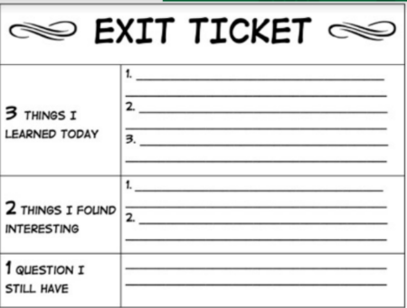
9. Enhance retention and transfer  15 minutes | After they share an activity in the group. Find at least one or two new activities in the group chat that they can use in their next class. Ask them to apply a new activity from this module in their next class. If it is a success, tell their colleague "Thank you!" and why it was effect

