Workshop Training Plan Template

Workshop Title: Module 9: Facilitating Discussions and Debates

Workshop Description: Language is what unites people. Whether it is through brief interactions or deep conversations, communication comes in many forms. In this module, you will explore how discussions and debates can strengthen students’ language proficiency and confidence. These are two forms of communication that also encourage critical thinking and build intercultural competence.

Nine Events | Description of Instructional Event | PowerPoint Slides or Handouts
1. Gain attention  5 minutes | Jazz chants | Worksheets with chants
2. Inform learners of objectives  3 minutes | By the end of the workshop, teachers will be able to:  - describe the benefits of communicative language teaching through discussions and debates and how to use them in the EFL classroom  - explore various cooperative learning and interactive language tasks and strategies that build language proficiency and a classroom discourse community  - develop higher order thinking questions that encourage critical thinking in the classroom  - design ways you plan to integrate and manage learning activities that support a communicative approach for language learning in your classroom | PPT slide  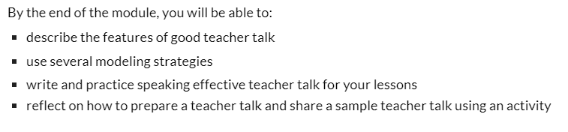
3. Stimulate recall of prior learning  5 minutes | Stimulate participants beliefs in facilitating discussions and debates. As well as setting expectations for these activities in their language classroom...  Ask “How do you organize debates and discussions in your classroom?  How do you set expectations for debates and discussions?”  What strategies do you use to involve all participants?  Mini-lecture on the reasons behind the necessity of using some strategies to organize debates and discussions? | Question:  “What is debate?“  “What is discussion?”  “How do you organize debates and discussions in your classroom? How do you set expectations for debates and discussions?”  What strategies do you use to involve all participants?  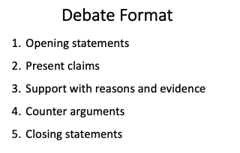
4. Present the content  20 minutes | Demonstrate the videos from TETE:  Video 1. Discussion activities. After watching Video 1 the participants apply “Tower Build “ activity for stimulating discussions  Video 2. Debates in the language classroom. | https://sites.google.com/view/mason-tete/module-9-facilitating-discussions-and-debates?authuser=0#h.4dg8ph8jectx  https://sites.google.com/view/mason-tete/module-9-facilitating-discussions-and-debates?authuser=0#h.8rgvedbu5ew
5. Guide learning  Give One and Get One information gap activity  20 minutes | Reading the Articles  Article 1: Navigating Discussions and Debates in the EFL Classroom by Kelley Webb
6. Elicit performance (practice)  10 minutes | Consider the ways you already use or would like to integrate and manage learning activities that support a communicative approach for language learning in your classroom. Think about the following questions and write down some thoughts in your journal.  - What do “discussions” and “debates” look like for you? How about in your classroom instruction?  - How do you usually get students interested in discussing a new topic in your class?  - How do you generally select the topics of discussion for class? Do students have any choice or input in selecting topics?  - What are your challenges and possible solutions for facilitating discussions and debates in your language classroom?
7. Provide feedback  PQP  5 minutes | Participants work in small groups to demonstrate their adapted activities. | P-Praise  Q-Question  P-Polish
8. Assess performance  5 minutes | - Participants write 1-2 paragraphs to reflect on Module 9.  - Collect their Exit Tickets to assess participants’ understanding of workshop content.
9. Enhance retention and transfer  5 minutes | Before leaving the workshop ask participants which activities of the workshop they liked and how they will change them or implement without change in their classes. | 

