**Handout 2**

**The 6 Principles®**

**FACILITATION GUIDE: Overview of the 6 Ps**

**Purpose**

This handout will provide an overview of The 6 Ps and some best practices for each.

**Materials**

* 1 **Overview of the 6 Ps** handout for each participant (pages 2–3 of this document)

**Preparation**

1. Make copies of **Overview of the 6 Ps** for each participant (pages 2–3 of this document).
2. Determine how you will show the corresponding videos.

**Procedure**

1. Direct participants to the **Overview of the 6 Ps** handout(pages 2–3 of this document) when showing the coordinating videos.

**The 6 Principles®**

**Overview of The 6 Principles for Exemplary Teaching of English Learners**

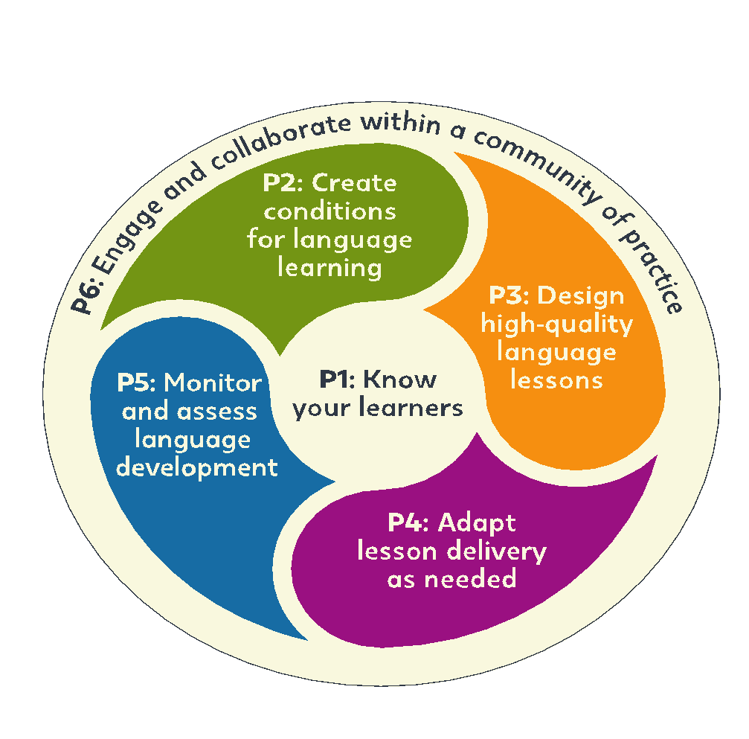

**PRINCIPLE 1: Know your learners.**

* Best Practice 1: Teachers collect information about their students.
* Best Practice 2: Teachers plan lessons to collect and use information about students.

**PRINCIPLE 2: Create conditions for language learning.**

* Best Practice 1: Teachers create a positive and organized classroom where students feel happy and comfortable.
* Best Practice 2: Teachers demonstrate that they have high expectations of all students.
* Best Practice 3: Teachers plan lessons that motivate students.

**PRINCIPLE 3: Design high-quality lessons for language development.**

* Best Practice 1: Teachers prepare lessons with clear language objectives and share the objectives with their students.
* Best Practice 2: Teachers use oral and written English that students can understand.
* Best Practice 3: Teachers have active classrooms where students can actively practice English with interesting topics.

**PRINCIPLE 4: Adapt lesson delivery as needed.**

* Best Practice 1: Teachers check student understanding often.
* Best Practice 2: Teachers adapt their teaching when it is necessary.

**PRINCIPLE 5: Monitor and assess student language development.**

* Best Practice 1: Teachers take notes of student errors.
* Best Practice 2: Teachers give prompt and specific feedback to students in a positive and effective way.
* Best Practice 3: Teachers use a variety of assessments to inform teaching and improve learning.

**PRINCIPLE 6: Engage and collaborate within a community of practice.**

* Best Practice 1: Teachers regularly do self-reflection.
* Best Practice 2: Teachers regularly participate in professional development.