PLAN – TESOL 6 principles/ Principles 3-6

| Workshop Segments and Time |  | Participants | Date | Training Venue |
| --- | --- | --- | --- | --- |
| **Principle 3: Design high-quality lessons for language development**   * teachers prepare lessons with clear language objectives and share the objectives with their students. * teachers use oral and written English that students can understand * teachers have active classrooms where students can actively practice English with interesting topics   I will present by showing on the screen and demonstrating or modeling examples.  Participants practice giving simple directions with patterned language such as hand clapping, rhymes and dividing tasks into smaller patterns. I also use activities like ‘Numbered heads together’ , ‘Think, pair, share’ | 1 hour | Shimbay RPMs |  | School #40/14/49  Shimbay region |
| **Principle 4: Adapt lesson delivery as needed.**   * teachers check student understanding often * teachers adapt their teaching when it is necessary   Together with the participants we practice student understanding activities such as ‘Turn and Talk’, ‘Think-Pair-Share’, ‘Response cards’, ‘Thumbs up/down’ and also some examples of teacher, material and social supports. | 1 hour | Shimbay RPMs |  | School #40/14/49  Shimbay region |
| **Principle 5: Monitor and assess student language development**   * teachers take notes of student errors * teachers give prompt and specific feedback to students in a positive and effective way. * teachers use a variety of assessments to inform teaching and improve learning   I will present through PPT and discuss it with the participants | 1 hour | Shimbay RPMs |  | School #40/14/49  Shimbay region |
| **Principle 6: Engage and collaborate within a community of practice.**   * teachers regularly do self-reflection * teachers regularly participate in professional development   I will show Principle 6 video. Participants do micro teaching. PQP. | 1 hour | Shimbay RPMs |  | School #40/14/49  Shimbay region |

**Handout 1**

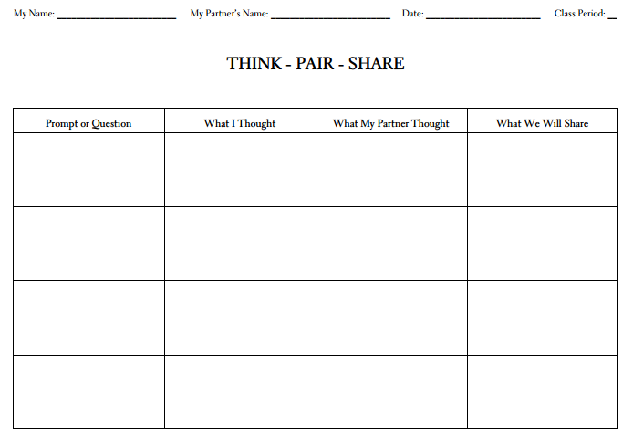

**Handout 2**

**The 6 Principles®**

**3–2–1 Uzbekistan!**

**Language Objectives**

* Answer questions about a region in Uzbekistan.
* Ask questions about other regions in Uzbekistan.

**Helpful Vocabulary**

* famous = many people know about it
* landmark = a famous place to visit
* tourist = a person who travels for fun

**Directions**

1. Write the name of your assigned region of Uzbekistan.
2. Work with your table-group to add the 3–2–1 information in the boxes.
3. Transfer all of the information to poster paper.
4. Prepare to **answer** questions about your region and **ask** questions about other groups’ regions. You can add drawings if you like.

**Why Do People Travel to Uzbekistan?**

**Region _____________________**

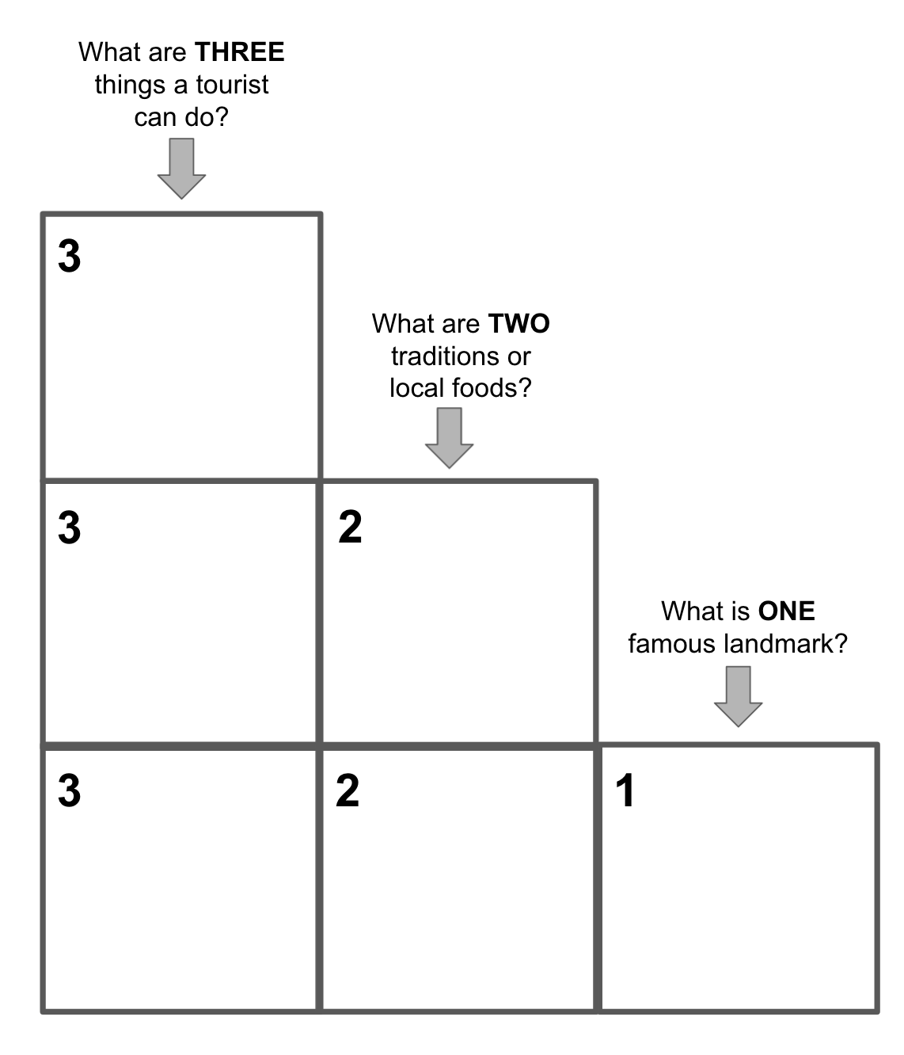

**Handout 3**



**The 6 Principles®**

**Response Cards**

**Directions**

1. Hold your handout up to read “True” when you hear/read a true statement.
2. Turn your handout over to read “False” when you hear/read a false statement.



**Handout 4**

**The 6 Principles®**

**Activity Tracker**

| **Activity** | **What did we do?** | **How did we do it?** | **Why did we do it?** | **How can I adapt it?** |
| --- | --- | --- | --- | --- |
|  |  |  |  |  |
|  |  |  |  |  |
|  |  |  |  |  |

**Handout 5**

**The 6 Principles®**

**Around the Clock**

**Directions**

1. Write your name and a short note about a favorite take-away from the two-day workshop.
2. Move around the room and ask your colleagues their name and a favorite take-away.
3. Write one colleague’s name and take-away next to each hour on the clock. IMPORTANT: You cannot repeat a name or a take-away.
4. Move quickly! You only have five minutes to fill your clock.

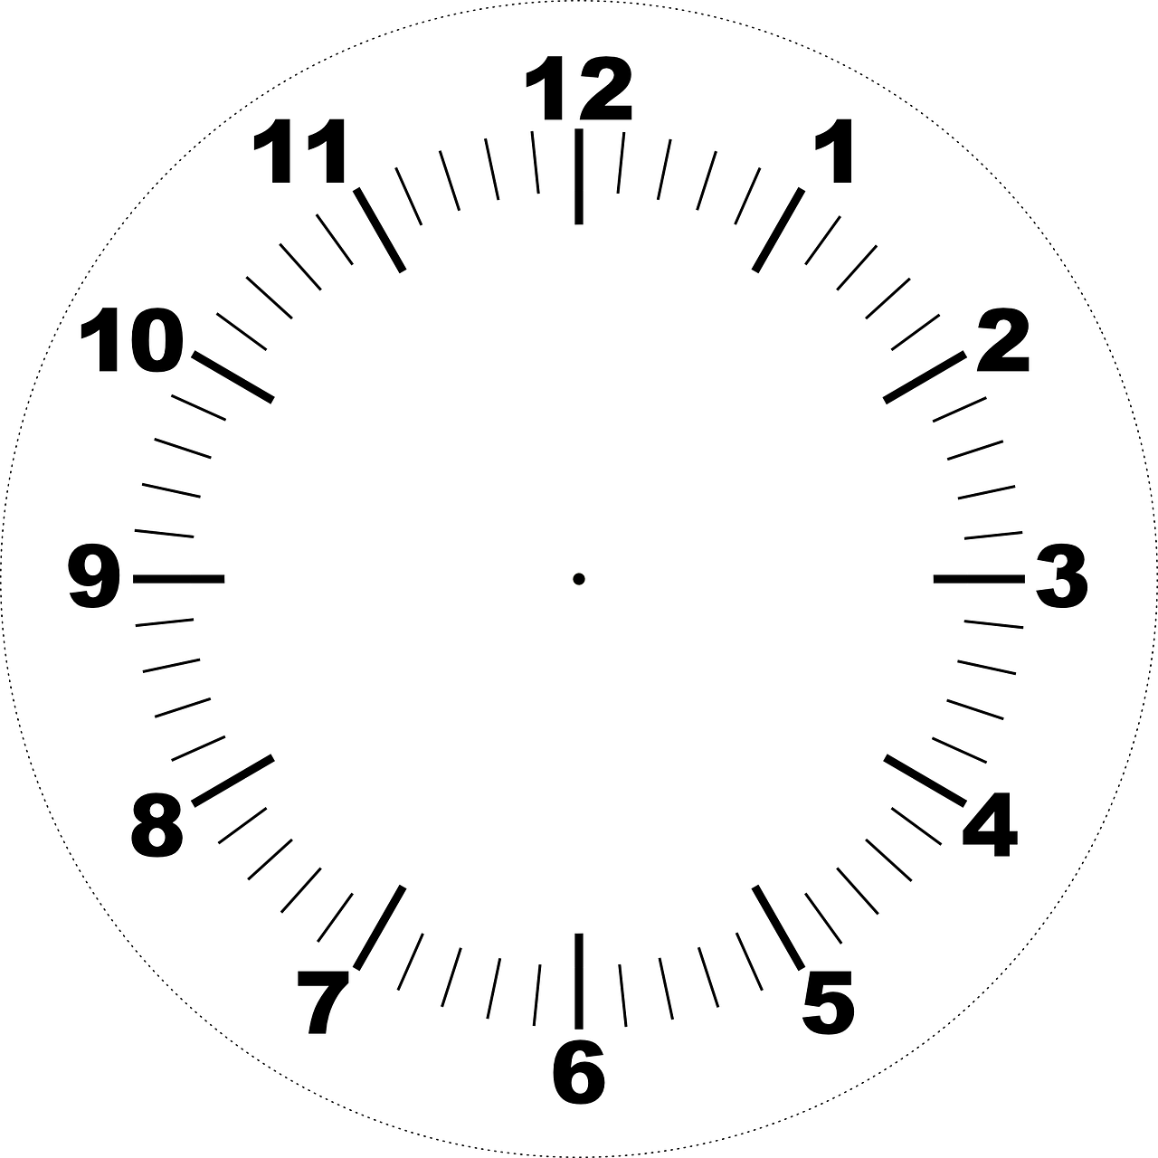

**Handout 6**

**The 6 Principles®**

**Find Someone Who . . .**

**Directions**

1. Read the statement in each box.
2. When I give you a signal, walk around the room for five minutes. Ask other people questions to see if they fit one of the statements below (e.g., “Have you ever traveled by train?”).
3. Write their name in the appropriate box.
4. Sit down when you finish or when I give you a signal.

| **I have traveled by train.** | **I study the history of a new place before I go there.** | **I have a passport.** | **I would like to visit the United States.** |
| --- | --- | --- | --- |
| **I like to practice English when I travel.** | **I have visited the United States.** | **I like to try new foods when I travel.** | **I have visited more than five countries.** |
| **I like to collect money from different countries.** | **I don’t like to travel.** | **I have never traveled to a different country.** | **I like to visit museums.** |
| **I enjoy helping visitors learn about Uzbekistan.** | **I take a lot of pictures when I travel.** | **I prefer to travel alone.** | **I want to travel to space.** |

**Handout 7**

**The 6 Principles®**

**PQP Feedback**

**Directions**

After each group presents their lesson, offer them PQP (Praise–Question–Polish) Feedback by answering these three questions:

* **Praise** – Make at least **one positive comment** about their microteaching.
* **Question** – Ask at least **one question** about their microteaching.
* **Polish** – Make at least **one suggestion** to help them improve their microteaching.

| **Praise** | **Question** | **Polish** |
| --- | --- | --- |
|  |  |  |

**Principle 3:** [**https://youtu.be/2-CWwdrtKd4**](https://youtu.be/2-CWwdrtKd4)

**Principle 4:** [**https://youtu.be/CWR5MmJv-xw**](https://youtu.be/CWR5MmJv-xw)

**Principle 5:** [**https://youtu.be/fTokuUOeuZU**](https://youtu.be/fTokuUOeuZU)

**Principle 6:** [**https://youtu.be/xm6EHPni5dE**](https://youtu.be/xm6EHPni5dE)