**Workshop Training Plan**

**CT: Yusupova Umitgul Toktarbayevna**

**Workshop Title:** Building Routines in English

**Workshop Description:** This interactive workshop will help you explore different classroom routines you can apply to your teaching context while using English. Listeners learn the purpose and examples of classroom routines to enhance the use of English in your communicative classroom

Presenters are: Umitgul Yusupova. Time limit is: 4 hours

|  |  |
| --- | --- |
| **Gagné’s Nine Events of Instruction** | |
| **1. Gain attention** | ***Warm-up activity:***  ***Activity Turn and Talk;*** Trainees will turn to their elbow partner and talk about why classroom routine is important for language learning.   1. Why classroom routines are important in the classroom ? 2. Some examples of classroom routines 3. How do you use classroom routines in the classroom ? 4. What are the benefits of classroom routines ? |
| **2. Inform learners of objectives** | By the end of the module, trainees ***will be able to:***  ∙ describe the purpose and process of good instructional routines using English to maintain a well-managed and communicative learning environment. §  ∙ apply some of the new classroom routine expressions in the classroom  ∙ share some of the effective instructional routines you want to use in your current classroom to increase the use of English |
| **3. Stimulate recall of prior learning** | Stimulate trainees’ beliefs in Increasing Classroom Interaction asking questions:   * What are some of your favorite classroom routines to start-up your class and why do you use them? |
| **4. Present the content** | ***Video Presentation*** about building routines in English  Video 1: “Start Up” Language Routines  Link to YouTube: <https://youtu.be/juq_lPcyFfM>  Video 2: Do Now & Wrap-Up  Link to YouTube: <https://youtu.be/Ld0_3Ph8bRw>  Video 3: Daily Mingle  Link to YouTube: https://youtu.be/Ld0_3Ph8bRw |
| **5. Guide learning** | Create a classroom jobs board  Participants make chart that lists the classroom job, the associated responsibilities the frequency with which the role needs to be carried out and the name of the current student in the role. The first three items can be directly written on the chart, and the student names can be put on cards or pieces of paper that can be moved around when jobs change. |
| **6. Elicit performance (practice)** | Group work  Participants will create an English classroom routines  Classroom routines for everyday use of English  Based on what they learned, participants create a new classroom routine they would like to use regularly in their current teaching context. They briefly describe who their learners are, when would you they this instructional routine, and why they believe it would be effective. |
| **7. Provide feedback** | * In groups, participants demonstrate their plan to build classroom routines in the classroom * Pass out slips of paper for participants to write down feedback using Praise-Question-Polish. Collect the slips of paper and give them to the group * Give each group feedback using P-Q-P |
| **8. Assess performance** | ***1) Exit Ticket***  Before they leave, give participants a piece of paper with the 3-2-1 Exit Ticket asks then to fill out  Collect the Exit Tickets to assess participants’ understanding of workshop content |
| **9. Enhance retention and transfer** | Writing reflection on checking comprehension and giving effective feedback. Using ***exit ticket method***. Explaining how exit ticket works. |

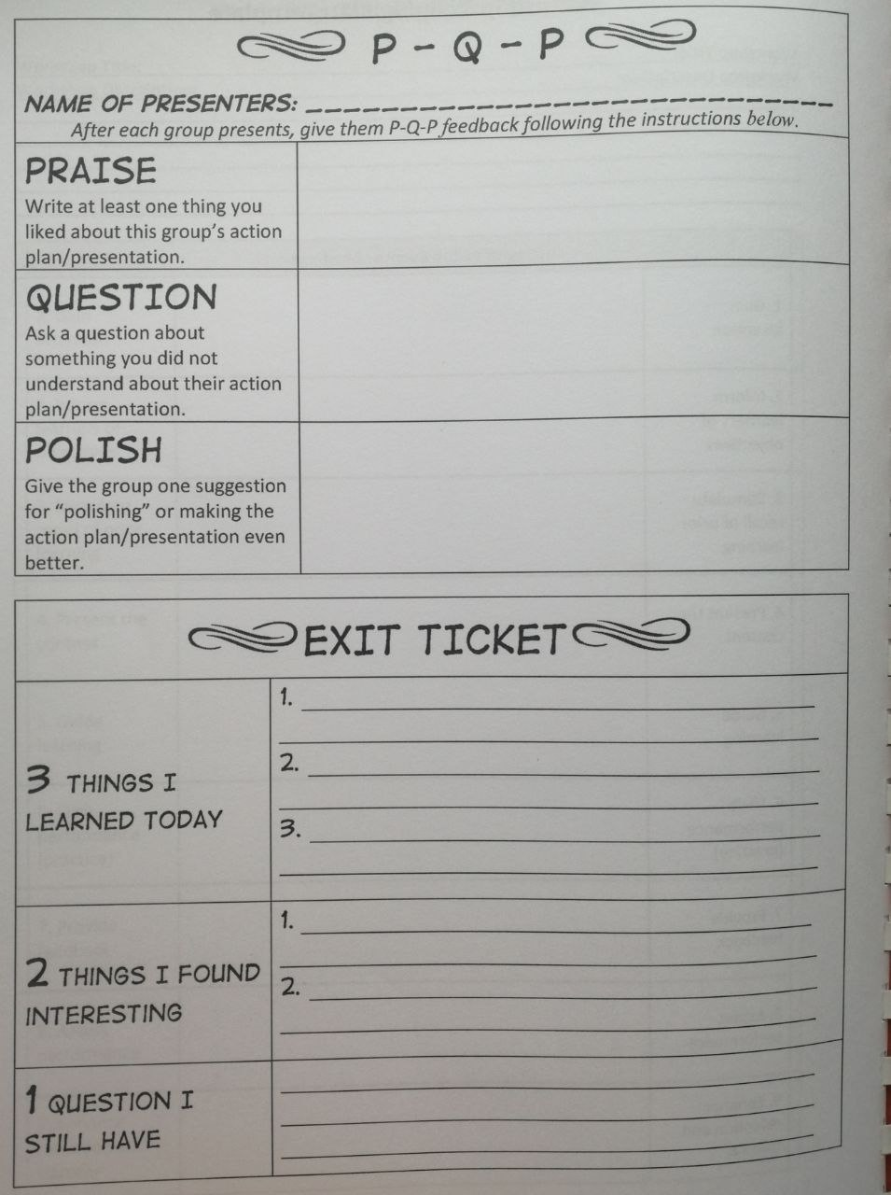

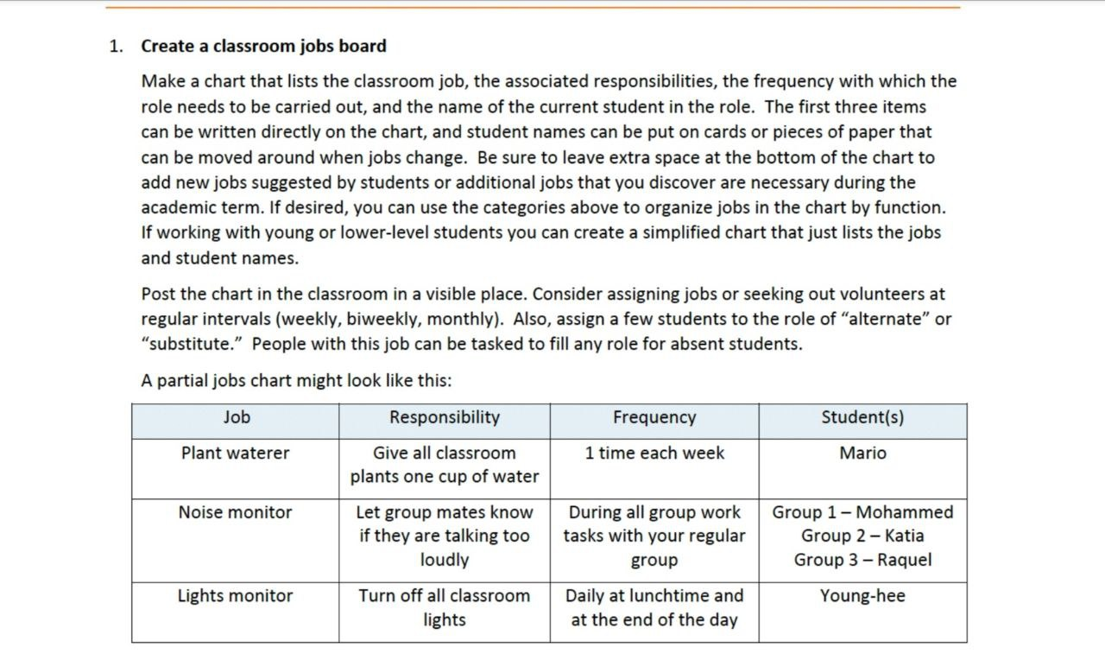

**Create a Classroom Job Board**

|  |  |  |  |
| --- | --- | --- | --- |
| **Job** | **Responsibility** | **Frequency** | **Students** |
|  |  |  |  |
|  |  |  |  |
|  |  |  |  |
|  |  |  |  |

**Create a Classroom Routine**

|  |  |
| --- | --- |
| **Activity name:** |  |
| **Grade:** |  |
| **This activity is effective because:** |  |
| **Presenters:** |  |