**Modules 5 and 6**

**Prepared by Ayteshova Nursuluv CT 2 Karakalpakstan**

1. **Warm up: Three (Weird) Things in Common. (15 min)**

Get to know your group members. Have a conversation and identify three things that you all have in common with each other. The weirder, the better! Write them down on a piece of paper. You will have 15 minutes. Then each has the weirdest three things in common!

To prepare, create an anchor chart with question starters for this activity. Anchor charts are a great tool to support students with the language they need during a lesson. You can create them on poster paper and display them on the classroom walls or whiteboards where all can see them.

**Anchor Chart Question Starters**

**Do you like/love…?**

**Does anyone like/love…?**

**Do you have …?**

**Does anyone have …?**

**Have you ever …?**

**Has anyone ever …?**

1. **Activating prior knowledge (20 min)**

**(Beliefs about increasing student to student interaction.)**

**True/False response cards**

Activating background knowledge helps the learners to get involved and interested in the topic. Activating Prior Knowledge is important in students understanding, because it allows them and helps make connections to the new information. By using what students already know, it helps the teacher assist students with the learning process because it gives him/her an idea of what students know and what they still need to learn.

Printed TRUE/FALSE response cards will be given to the teachers and on the screen variety types of beliefs about increasing student to student interaction will be appeared one by one. By reading and discussing them, we can activate their prior knowledge.

1. I use only textbooks.
2. I never use authentic materials.
3. I extend the activities according to their level.
4. I try to add Internet resources to my lesson.
5. I use videos to have effective lessons.
6. I use graphic organizers to differentiate.
7. I don’t care my students level while they are doing tasks.
8. Activities should be the same for everyone.
9. I prefer traditional way of teaching.
10. I am always limited with the textbook activities.
11. I always use communicative activities to make my lessons enjoyable and useful.
12. Activities should be chosen to promote active learning.
13. Student interaction is the most crucial need.
14. I always have student centered lessons because I try to increase student to student interaction.
15. I used to teach only grammar.
16. **TETE video about increasing student to student interaction. (10 min)**

Teachers will watch a video about increasing student to student interaction after a hot discussion. While listening, participants should take notes about interaction and its role in the class and advantages. Every participant takes notes from the video for themselves.



Link to YouTube: <https://youtu.be/GfzQJdsbC2o>

1. **Discuss the taken notes from the video. (15 min)**

Discuss it with the group. After watching and discussing in a group, they will be able to describe the importance of student-to-student interaction in a language classroom, examine and use a variety of effective activities that promote meaningful interaction in a classroom, share different communicative activities that are effective for English learners.

1. **Find Someone Who Bingo… (Mingling activity) Group work (30 min)**

This video is about an Icebreaker Activity called Find Someone Who Bingo. This will help you increase student-to student interaction in your classroom.

To learn a language, we need to uselanguage. Our classrooms should be comfortable and inviting spaces that foster effective and meaningful interactions in English. Icebreakers are a perfect way to achieve this!

I will show you one Icebreaker activity called “Find Someone Who…Bingo”! In this Icebreaker, we need to prepare a Bingo Board for every teacher. Here is an example of a Bingo Board:

|  |  |  |  |  |
| --- | --- | --- | --- | --- |
| **1. Loves basketball**  **Do you…?**  **Name:** | **2. Thinks computer games**  **are a sport Do you…? Name:** | **3. Likes summer**  **Do you…?**  **Name:** | **4. Good at soccer**  **Are you…?**  **Name:** | **5. Thinks fishing is a sport**  **Do you…?**  **Name:** |
| **6. Hates to exercise**  **Do you…?**  **Name:** | **7. Likes to watch American football**  **Do you…?**  **Name:** | **8. Knows what sport Serena Williams plays**  **Do you…?**  **Name:** | **9. Write your own question**  **Do you…?**  **Name:** | **10. Has a pet**  **Do you…?**  **Name:** |
| **11. Speaks more than two languages Do you…?**  **Name:** | **12. Visited another country**  **Have you…?**  **Name:** | **FIND SOMEONE WHO…**  **BINGO!** | **13. Plays a musical**  **instrument**  **Do you…?**  **Name:** | **14. Watches Hollywood**  **movies**  **Do you…?**  **Name:** |
| **15. Is an only child**  **Are you…?**  **Name:** | **16. Rides a bike to school**  **Do you…?**  **Name:** | **17. Write your own question: Have you…?**  **Name:** | **18. Gets up before 6 am**  **Do you…?**  **Name:** | **19. Loves running**  **Do you…?**  **Name:** |
| **20. Drinks tea**  **Do you…?**  **Name:** | **21. Is left- handed**  **Are you…?**  **Name:** | **22. Loves to read books**  **Do you…?**  **Name:** | **23. Likes spicy food**  **Do you…?**  **Name:** | **24. Write your own question:**  **Are you…?**  **Name:** |

This Icebreaker Activity will help your students get to know each other better and encourage real communication in English. Here are a few additional tips for using this icebreaker.

If your students are more advanced, you can prepare them to ask a follow up question

to generate more interaction. For example, Student A can ask Student B, “Do you love to read books?”. If the answer is “yes,” Student A can write down Student B’s name in the box. Then, Student A can ask, “What is your favorite book?” or “What book are you reading now?”.

Finally, I have a good wrap-up tip for this activity. At the end of the icebreaker, you can collect responses as a whole group. There are questions that will naturally encourage more communication, such as who thinks fishing is a sport or who hates to exercise. Students who gave these responses should be encouraged to explain why.

This wrap-up extends communication and helps your students get to know each other even better. I hope you found Find Someone Who Bingo useful. Remember you can adapt this kind of Icebreaker activity with different topics and questions to align with your curriculum.

1. **Coffee Break (20 min)**
2. **Small Talk (Pair work with elbow partner) (15min)**

**Small talk about writing good objectives of your lessons to activate prior knowledge about clear and specific objectives.**

Participants will discuss the given topic with their elbow partners and then in a small group of 4 to share ideas and experience on this topic. It is used to activate the prior knowledge because they are going to learn a new material on how to write clear and specific objectives for the lessons. After the discussion, they will watch a video and explore ideas for how to write good objectives, how to sequence activities, and how to improve our instruction through reflective teaching.

Remember to start with SWBAT and use concrete, observable actions to write a good objective. Then you should be able to plan your lesson step by step to reach that objective, like a recipe that ends in a very delicious dish.

1. **TETE video about PTRA (Plan, Teach, Reflect, Adjust) (30 min)**

**Activating reflective teaching**

Participants will watch a video about **PTRA** (Plan, Teach, Reflect, Adjust) and activating reflective teaching. While watching, participants should take notes from the video. After it, CT checks comprehension by showing ***Thumbs up and Thumbs down.***



This video will demonstrate how to sequence activities in a lesson to promote a

meaningful language learning environment throughout instruction.

Link to YouTube: <https://youtu.be/B7BXBQma8h8>



This video explains the role that reflection plays in teachers' daily instruction. It also provides key questions you can ask to develop your reflective practice.

Link to YouTube: <https://youtu.be/n4lK_P79mVs>

**Six-Step Lesson**

There are different ways to set up a lesson. However, some lesson plans have 6 steps that look similar to this:

**Six-Step Lesson**

**1. Warm-up**

**2. Presentation**

**3. Practice**

**4. Application**

**5. Wrap-up/Assessment**

**6. Follow-up**

This lesson plan structure will encourage you to present new language through receptive tasks, such as listening and speaking before asking students to produce speaking or writing tasks.

In addition, it provides more controlled production activities before giving students a chance to produce more independently. This is how we scaffold language learning for young learners through our lesson planning. You may have a different type of lesson plan structure in your school, but you can still try to plan your lessons using these simple rules. Happy planning!

1. **TETE video “Writing Good Objectives” (20 min)**

Participants will watch a video about writing good objectives for the lessons. While watching, the participants take notes on how to write clear and specific objectives.



This video will emphasize the importance of writing good objectives and suggest how to write good objectives.

Link to YouTube: <https://youtu.be/IHo7eqElKg0>

1. **Checking Comprehension. Group Work (25 min)**

After watching the videoabout writing good objectives for the lessons, they use one of the given graphic organizers provided by the CT or they will be given a choice to explain the topic and its steps. They work in a group of 3 or 4. Graphic organizers can help to visualizeand construct ideas, organize and/or sequence information, plan what to write, increase reading comprehension, brainstorm, organize problems and solutions, compare and contrast ideas, show cause and effect, and more.

Graphic organizers are a helpful learning tool for students of all ages to organize, clarify, or simplify complex information—they help students construct understanding through an exploration of the relationships between concepts.

**Graphic organizers**

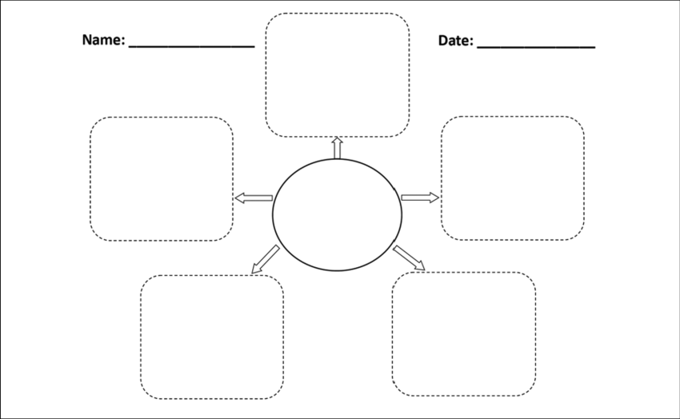

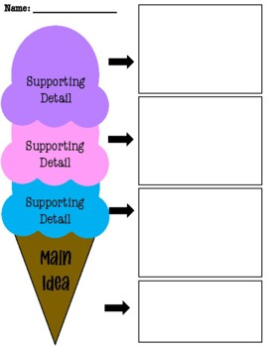

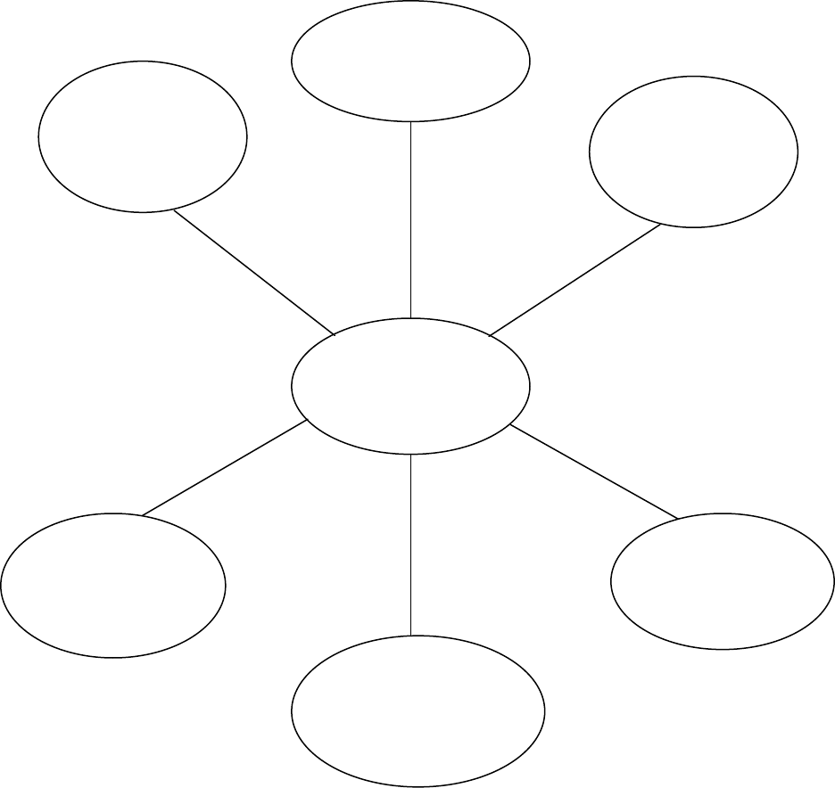

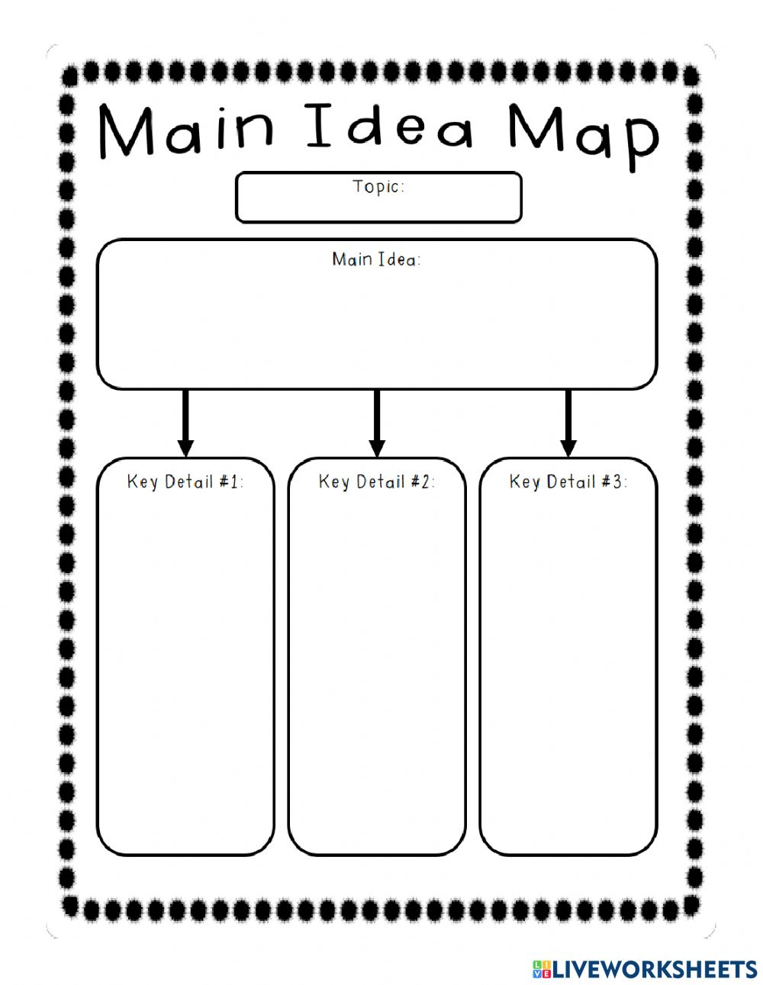

1. **Production Part (30 min)**

Design effective lesson plans for English learners using the following steps: warm up, presentation, practice, application, and wrap up. Participants should write short lesson plans taking into account all materials. Participants will work in groups of 4.

**Six-Step Lesson Plan Template**

|  |  |
| --- | --- |
| Lesson Title | |
| Student profile | Description of your students (e.g., age, grade, proficiency level) |
| Skills to be emphasized | Listening, speaking, reading or writing |
| Language focus | *Grammar:  *New vocabulary: |
| Objectives | By the end of this lesson, SWBAT… |
| Materials | Materials needed for lesson activities |
| Lesson Plan | |
| 1. Warm-up | The teacher starts the lesson with activities that create interest and excitement for the lesson, link the day’s lesson with previous lessons, and activate background knowledge about the content and the new language. |

|  |  |
| --- | --- |
| 2. Presentation | The teacher presents the relevant vocabulary and language structures in a meaningful context, like a story or a song, and checks comprehension.  Usually this input is presented through listening or reading. |
| 3. Practice | The teacher gives students the opportunity to practice new language through controlled activities. Students practice using new language in predictable ways through post-listening or post-reading activities that include speaking and writing. |
| 4. Application (Production) | The teacher gives the students the opportunity to practice new language through free or independent activities. Students use the new language more independently to communicate something that is meaningful to them. Application activities almost always involve speaking or writing. |
| 5. Wrap up/Assessment | The teacher presents a final activity that reviews what was learned in class and assesses if learners have achieved the lesson objective. |
| 6. Follow-up | The teacher may assign homework or connect today’s lesson to the next lesson. |

1. **Home** **task: (10 min)**

* Choose a lesson plan you have used before and make any changes or improvements to reflect what you have learned about communicative lesson planning
* Create one activity to increase student to student interaction.

Thanks for your attention.