**Module 2**

**Giving Clear Instructions**

1. **Warm up: Stand Up / Sit Down 10min**

Purpose: This activity will serve as a community building activity to help participants get to know some things about each other.

Materials: 1 large copy or PPT slide of the Stand Up / Sit Down statements (Step 3 of the Procedure below)

Preparation: Prepare 1 large copy or PPT slide of the Stand Up / Sit Down statements (Step 3 of the Procedure below).

Procedure –Discuss the directions for the activity.

1. Listen to each statement. If the statement is true for you, stand up.

If it is not true for you, sit down.

2. Look around the room so you can learn new information about your colleagues.

3. EXTENSION: Ask follow-up questions to people near you.

Model the activity by using these statements one by one:

I live in Uzbekistan.

I have taught English for more than 15 years.

I have a pet.

Use the following statements for the activity:

Stand up if you . . .

like to visit new places.

have a passport.

have traveled by plane.

have visited the United States.

would like to travel to space.

can stand on one foot for 10 seconds (show us!)

This activity helps teachers to create friendly atmosphere. Teachers will have a chance to speak in English, think in English and they will relax doing this activity.

1. **Background knowledge 10 min**

**How should teachers give instructions?**

**Brainstorm “ challenges while giving instructions” Identifying problems and wiring tips for clear instructions**

Teachers will be divided into three groups. They are going to work on paper presentation. Looking back to their teaching .Each teacher thinks about his or her lesson : “How should teachers give instruction?” Then they will share their answers with peers and with a group. Teachers can use graphic organizer to express their opinions about giving instructions and identifying problems.

1. **TETE video about Giving Clear Instructions (15 min)**

Before watching the video teacher asks questions to brainstorm them and explains to take notes about necessary information in the video.

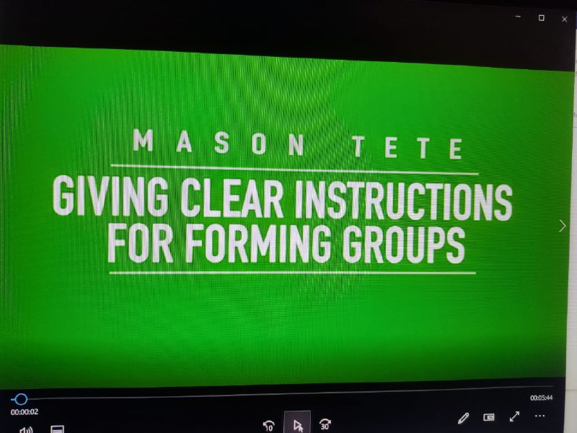

Link to you tube: <https://youtu.be/t8HvGLe68Sk>

Video 2: Teacher Talk for Managing Activities

1. **Discuss the taken notes from the video. (10min)**

**Think aloud can support learner’s language development and critical thinking. As teachers model, students can also be given opportunities to think and speak using these strategies and expressions. `**

**Giving clear instructions : Using Think aloud**

|  |  |
| --- | --- |
| **Think aloud strategies** | **Sample expressions** |
| **1 Prediction** | **I predict**  **In the next part I…**  **I think** |
| **2Questioning** | **Why did…..?**  **What did….?** |
| **3 Visualizing** | **I see…**  **I picture….**  **I feel….**  **My favourite part …** |
| **4 Clarifying** | **I got confused when….**  **I am not sure of …..**  **I didn’t expect…..** |

Teachers will be distributed with handouts

What are the effective instructions?

What are the main concepts ?

What makes instructions clear and understandable?

They will discuss and analyse the questions and share their opinions.

1. **Coffee Break (10 min)**
2. **Round Table discussion share ideas with your peers and with the group (10min)**

**Teacher look at power point presentation and try to find correct answer for the questions:**

1. Giving instructions: Look at each pair of sentences and choose the one that is TRUE. 1. a) You should use polite language otherwise students will get offended. b) You should use simple language so the instructions are clear.
2. Answer Key
3. b) You should use simple language so the instructions are clear. – TRUE Comment: If you are too polite, you may end up using complicated language that is difficult to understand
4. a) You shouldn’t do a demonstration because it takes far too much time. b) You should do a demonstration so students can see the activity in action.
5. b) You should do a demonstration so students can see the activity in action. -TRUE Comment: Doing an example is a very concrete way of giving instructions.
6. a) You should use questions to check key aspects of the instructions. b) You should use questions to check all aspects of the instructions.
7. a) You should use questions to check key aspects of the instructions. - TRUE Comment: If part of your instructions are obvious, for example, “work in pairs”, then it is not necessary to check this aspect of the activity. Check aspects that are more confusing for students.
8. a) You should hold up worksheets when giving instructions so that students look at you. b) You should hand out worksheets and then give instructions so students can read what they have to do.

Read Explore ideas for giving clear directions by reading at least two articles.

Article 1: Common Mistakes in Teacher Talk by Hyunsun Chung and Woomee Kim

Article 2: Giving Effective Instructions: Using Think Aloud by Hyunsun Chung and Woomee Kim