TOT: Week II - Room 1 - Group 1

See the Action Plan document for feedback about this workshop plan as well as your action plan.
~ From the George Mason University Academic Team

Workshop Training Plan Template
Workshop Title: Module 2 Giving Clear Instructions
Workshop Description: Through this module, you will explore the challenges, purposes, and ways of giving clear instruction in your English classrooms. You will learn how to give clear instructions using English and engage students to participate in communicative learning tasks.
Gagné’s Nine Events of Instruction |  |  | Time
1. Gain attention | Put a twist on the old “If you can hear me, put your hands on your head.” Teacher says “‘If you can hear me, put your hands on your head, on your shoulders, knees, etc’, but as I make the motions, I will say a different body part. So, they are watching me put my hands on my shoulders, but I am saying,’Hands on your hips’. It’s hilarious! It takes them a while to figure it out and really gets them to focus on me.” |  | 20  minutes
2. Inform learners of objectives | Read through the objectives on PPT slide:  -By the end of the module, you will be able to:  -Learn good  teacher talk characteristics  -Apply some modeling strategies  -Learn how to write and practice speaking effective teacher talk for their lessons  -Demonstrate a simple teacher talk using an activity |  | 10 minutes
3. Stimulate recall of prior learning | Stimulate participants beliefs about giving clear instructions.  Article 2: Giving Effective Instructions: Using Think Aloud by Hyunsun Chung and Woomee Kim.  Think Aloud can be used by EFL teachers to model classroom language and critical thinking for students. This article provides teaching tips on using Think Aloud to give effective instructions to students.  Source: Chung, H. & Kim, W. (2021). Modeling and effective Instructions. English Speaking Nation for Uzbekistan Program.  activity  handout that guides students to talk about  their interests and hobbies.  Figure 2. A sample activity handout.  How do you like to spend time on weekends?  From the list of activities below:  • Circle three things you like to do.  • Cross out three things that you never do.  • Write three other things you like to do in  your free time.  Activities:  watch movies  chat with friends  work out  read  listen to music  cook  garden  swim  go to the library  visit family  take care of younger siblings  ride a bike  go hiking  play basketball  Next, two different teacher talks are presented in the examples that give task  instructions to students. As you read these examples, consider which version of the directions you use more often.  Figure 3. Teacher talk examples.  Example A  Teacher distributes the handouts listing the hobbies and activity direction to class.  T: “Now you are going to talk about things you like to do when you have some free time during the weekend. I want you to circle three things you  like to do, cross out three you don’t like to do, and add three more things you like to do. After you finish, talk to people in class and find the person  who has the most in common with you. Ask them the questions at the bottom of your handout.”  Example B  T: Dildora, what do you like to do on the  weekend?  D: I like to read.  T: So do I. (T places sample handout on overhead and circles ‘read’.) Do you ever garden?  D: No.  T: Neither do I. (T crosses off ‘garden’. T distributes handout to class.) Akbar, what do you do on the weekend?  A: Play football. (T uses a questioning look.) Do you see football on the list? (T points to overhead.)  Class: No. (T asks Akbar to write it on the blank. T and Class now read instructions together.)  T: What do you circle?  C: Things we do on the weekend.  T: What do you cross out?  C: Things we don’t do on the weekend.  Class completes part 1 of the handout individually and then T gives instructions for part 2 through a similar demonstration.  Which version of giving directions do you use more often? Can you explain the main differences between the two examples? In Example A, the teacher gives a lengthy explanation of the activity, but does not demonstrate what the students will do. The teacher cannot tell the students’ comprehension of her instructions because she does not interact with them. In Example  B, the teacher spends time walking through the activity with the students, modeling the process, and asking questions to guide meaningful conversation. She is using the “Less is more” motto to give clear instructions. |  | 25 minutes
4. Present the content | -Watch videos “ Giving clear instructions for forming groups”, “Teacher talk for managing activities”  - PPT about applying effective TT for their lessons  Article 1: Common Mistakes in Teacher Talk by Hyunsun Chung and Woomee Kim  This article shows some of the common mistakes in teacher talks, but how these can be overcome through reflection and practice. Source: Chung, H. & Kim, W. (2021). Common mistakes in teacher talk. English Speaking Nation for Uzbekistan Program.  Common mistakes can be found in teacher talk, but can be overcome with reflection and practice.  Teachers will make mistakes in their teacher talk. It’s only natural. However, as  teachers learn to analyze the speech and behavior in their teacher talk, these  mistakes will become less common with consistent practice. Take a look at the  following examples of teacher talk. See if you can identify the teacher’s mistake in  Examples 1 and 2. Then compare the two teacher talk models in Examples 3 and 4 to  check their effectiveness.  Example 1.  T: What did you do yesterday?  S: It was a nice day, so, with my friends I  went to...uh...  T: To the park?  S: Uh...yes.  In Example 1, the teacher does not give this student the chance to think of the right  word, but suggests an answer when the student seems to struggle in giving a  response. This teacher may seem to be helping the student, but in fact takes away  the opportunity for the student to get it right and risks embarrassing the student in  front of others. It is good practice to wait a bit from suggesting possible answers until the student asks for support.  Example 2.  T: Carlos, please read sentence number  one on the handout.  S: “The young man goes to bed...”  T: “...at midnight.” Monica, please read  the next sentence.  Similarly, in Example 2, the teacher is a sentence finisher. This time, the teacher  fails to provide enough time to the student (Carlos) to figure out the unfamiliar  vocabulary and pronounce it on his own. This teacher definitely risks hurting the  confidence of this learner by quickly reading out loud the rest of the sentence and  impatiently moving onto another student. However, such mistakes can be overcome by first encouraging the student and giving  a little extra time to the student to figure it out on his own. When the student is  obviously struggling, the teacher may suggest,  T: What do you think this unfamiliar word  is? Let’s break it up and see if you recognize  any part of the word. “Mid” and...”night.”  That’s right!  Example 3.  T1: It was the best of times, it was the  worst of times.  T2: It was the best of times, (1 second  pause), it was the worst of times.  This example may be more obvious. The second teacher demonstrates the preferred way. Again, giving time seems to be critical  in successful teacher talk. That is the sign of the teacher considering the students’ levels and reception. When a teacher speaks naturally or reads out loud, giving even a one-second-pause in sentence breaks (often indicated by a comma or a period) can help students understand what they are  listening to or read better. This pause serves as a way for speech modeling when  students interact with each other as well. It especially makes a big difference for  beginner language learners because teachers so often don’t realize they are  speed talkers (or pause eaters).  Example 4.  T1: Now, I would like to write a question  on the board, asking you what you did  over the weekend. I am just going to grab  the chalk, which is on my desk. There it is.  I’ve got it. And...  S: Teacher, Is that the present perfect  tense in that sentence?  T2: As a matter of fact, yes. Because my dog was sick yesterday and the day  before, and he was still sick this morning. Remember, we use the present perfect,  among other things, to show that an action started at some point in the past  and continues until now....  Sometimes, teachers believe the more language input they give, the more learning  happens. That is not always true as you may have noticed in the two scripts. Especially, if the teacher is teaching a language using the  target language, s/he should be careful not to be a commentator or an over-explainer. So, which one do you think is a commentator and which one is an over-  explainer? We can agree that the first teacher talk example is a case of a commentator. Teachers can think that these comments  can work as Think Aloud language samples, but when giving clear instructions, all of  these side comments can distract students who are trying to determine the task  instructions. Unless it is necessary, it is best not to become a commentator to every  action you are thinking of doing. The second teacher talk is an example of an  over-explainer. The student asks a simple yes/no grammar question. When the  teacher gives extra information, the listening student can feel overwhelmed by  too much teacher talk. The best way to answer this student’s question is by simply  saying, “Yes it is.” You may explain the other form (grammar) related information  later in an appropriate time and plan. The emphasis on teaching English by using  English is broad because effective teacher talk can become a good communicative  model from which students learn. You can improve your teacher talk in your EFL  classroom by carefully reflecting on your instructional language and the behavior  that you model to students. For more examples of good teacher talk, feel free to watch this presentation by McCaughey (2017) from the American English teacher resource. |  | 60 minutes
5. Guide learning | - “Four corners” activity to give effective instructions    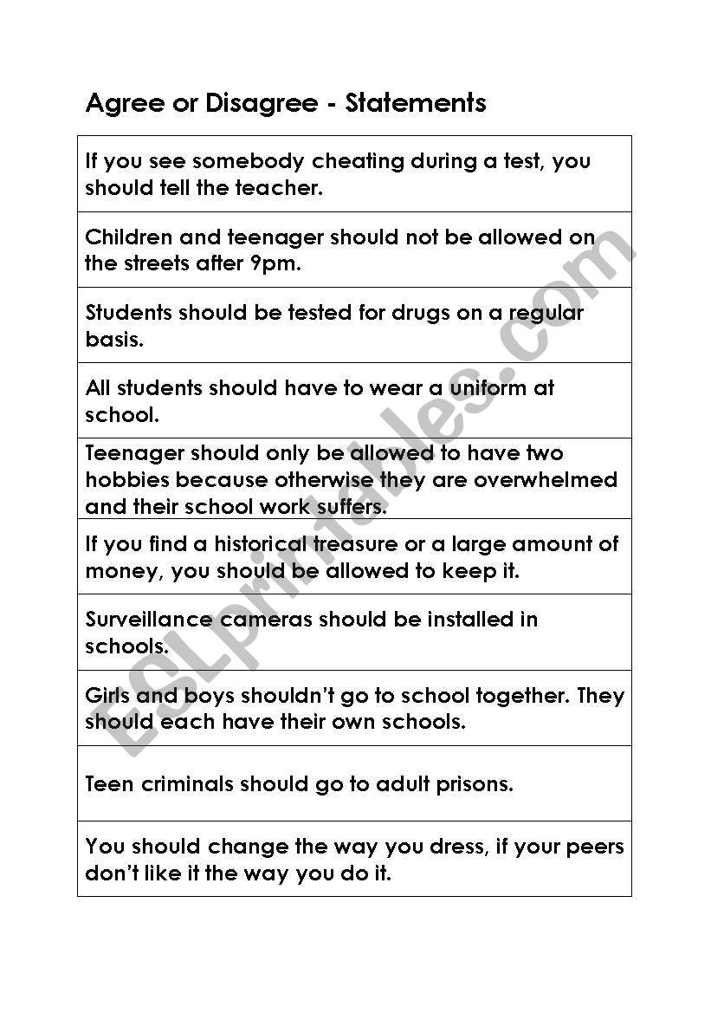  Jigsaw reading activity  10 Tips for Giving and Checking Instructions in an ESL Classroom  How can you make sure that your instructions are as clear and comprehensible as possible?  - Plan how you’re going to give the instructions before you go into the classroom, and make sure that you can explain them within the limits of the language which the students can understand. For example, the following instruction would be fine for an intermediate class, but would lose a group of beginners: “You’re going to hear a description of a famous person and you have to guess who it is.” For beginners, “Listen to my description of a famous person. Who is it?” would be far more comprehensible.  - Think too about the speed of your speech – slow down slightly if necessary – and insert pauses to allow students to take in each piece of information before you go on to the next.  - Make sure that your instructions are fully explicit – don’t take anything for granted. Because we are so familiar with the activity types, we often assume that certain things are obvious. How often have you explained an activity but forgotten to say explicitly “Don’t show your information to your partner” – only to find students happily doing just that.  - Also think about how much you’re going to explain at a time. If you have a long, complicated, or two part activity, don’t explain everything at once. Explain the first stage, and check that students have understood before you go on to the explanation of the next part. In some cases it is not necessary for the students to have an overview of the whole activity before they start. In this case, explain the first part, do the first part and then go on to the explanation of the second part.  - Don’t start the explanation until you have the students’ full attention. Make sure they have stopped whatever they are doing, are turned towards you and are listening.  - Even in the first lesson, use English wherever possible. “Get into pairs” won’t be understood, but “You two, you two and you two” plus a gesture pushing the students together will be.  - However, if you speak the students’ language, for very complex activities it may be more efficient to use the L1 for explanations. This can be gradually phased out as the students become more proficient:  a) at the beginning of the course, give the instructions in the L1, and then repeat them immediately, as simply as possible, in English.  b) later on reverse the order: give the instructions in English first, and in the L1 second.  c) as soon as possible, give the instructions in English only, but check comprehension by asking the students to repeat them back in their L1.  - Avoid using the imperative in your instructions. In most situations that the students will find themselves, it will not be an appropriate form to use. In the classroom it may be, but if they have constantly heard the teacher saying “Repeat!” there’s a good chance they’ll use it themselves:  Native speaker: And so I was dropped right in it. Student: Repeat!  Instead, use request forms – for example “Can you repeat that?” – which provide a good model for the students’ own use of the language. This is especially important if the imperative is more socially acceptable in the students’ own language (for example Italian) so that they are liable to transfer the use into English.  - Always check that students have understood your instructions before starting the activity. The question “Do you understand?” is as good as useless. Students may be too shy to admit that they don’t understand, or may think they understand when they actually don’t. Make sure they demonstrate their understanding. This can be done by:  a) asking them check questions – for example, for a roleplay : “OK, if you’re student A put your hands up… Right… who are you? And what’s your problem? And who is student B?”  b) asking them to repeat back to you the instructions. Don’t choose the strongest person in the group to do this. S/he is the one most likely to have understood and your check needs to be directed to the students who probably haven’t.  c) asking two students to demonstrate the activity in front of the class, or for a written exercise by eliciting the answers to the first two examples.  d) not giving instructions at all but asking students to look at the activity and tell you what they think they have to do. This can be useful for activity types which are already known the students.  - As soon as the students start the activity, go around quickly to each pair or group just to check they are on task. Don’t stop to help or monitor one group until you have checked them all. If only one group has not understood, then go back and help. If several groups are off track, then stop the activity and explain again, using the students who have understood to demonstrate to the others. |  | 50 minutes
6. Elicit performance (practice) | -to make a foldable based on Jigsaw reading article Ten Tips of Classroom Instruction.  Participants work individually to make their own foldables. |  | 25 minutes
7. Provide feedback | Write a reflection over the learnt material.  What did you know before the session?  What did you learn today?  What did you enjoy? | 20 minutes
8. Assess performance | - prepare 5 min group presentation of giving clear instructions  - each group makes one activity and their task is to give clear instruction and act in groups. | 20 minutes
9. Enhance retention and transfer | Before participants leave the workshops, ask them to write at least one new way to give effective instructions. | 10 minutes

Workshop Training Plan Template
Workshop Title: _The__Six principles__for exemplary teaching of English learners_______________________________________________________________
Workshop Description: ___To describe how to use 6 principles in teaching____English to teachers for creating more fruitful lessons in the process of teaching . Teachers should be informed in the most appropriate way how to facilitate learners according to given six principles . To create the most convenient conditions and explain how to use various kinds of activities for to achieve the main goal of the program.To find the way to the hearts of learners and try to be positive and creative teacher for any kind of learners.
___To provide positive feedback and design high-quality lessons for language developmen,adapt lesson delivery ,engage and collaborate within a community of practice.,____________________________________________________
__________________________________________________________________________________
__________________________________________________________________________________
__________________________________________________________________________________

Gagné’s Nine Events of Instruction
1. Gain attention | To create the most convenient English atmosphere,to demonstrate learners that they have high expectations of all students  To sing a song for learners and give them opportunity yo do the same for collecting information about them.
2. Inform learners of objectives | To create a positive and organized classroom where students feel happy and comfortable.To prepare lessons with clear language objectives and share the objectives with their students.
3. Stimulate recall of prior learning | To use the most appropriate activities for recall of prior learning.For example:True,False activities, jigsaw reading.
4. Present the content | To have active classrooms where students can actively practice English with interesting topics.To present the content in unusual way,but to use one of the activities according to six principles.For example: brainstorming.
5. Guide learning | Teachers use or and written English that students can understand.Teachers check student understanding often.To adapt teaching when it is necessary.For instance: scavenger hunt,thumbs up/down.
6. Elicit performance (practice) | To use best practices for learners step by step for improvement learners knowledge .Response cards,find someone who,textbook pages, jigsaw reading,3-2-1 Uzbekistan.
7. Provide feedback | To take notes of students errors,to give prompt and specii feedback to students in a positive and effective way.For example: P-Q-P..Praise,question,polish.
8. Assess performance | To use a variety of assessments to inform teaching and improve learning.These are the most appropriate ways for good learning and future success in the process of teaching.For example:clarification.
9. Enhance retention and transfer | Teachers should regularly do self-reflection and participate in professional development.

