TOT: Week 7 - Room 1 - Group 1

See the Action Plan document for feedback about this workshop plan as well as your action plan.
~ From the George Mason University Academic Team

Workshop Training Plan Template
Workshop Title: Module 7-Extending Textbook Activities
Workshop Description: In this module, you will have a chance to reflect on your teaching contexts and materials available to you. You will also explore ways to effectively adapt your teaching materials to foster a communicative classroom in English.
Gagné’s Nine Events of Instruction |  |  | Time
1. Gain attention |   How can this picture be adapted and used to give your students more chances to use their English communicatively? |  | 20 minutes
2. Inform learners of objectives | -analyze textbook lessons/activities and adapt content for appropriate and meaningful use to meet the learner needs and enhance classroom interactions  -use textbook, ancillary materials, and other relevant sources to develop an effective communicative lesson/activities appropriate for your learning environment |  | 10 minutes
3. Stimulate recall of prior learning | Activity: Think, Pair, Share.  Examine the teaching resources you currently use in your school, including your textbook. Choose a picture, a reading passage, written assignments and/or practice exercises from your resource. How can these be adapted and used to give your students more chances to use their English communicatively? |  | 25 minutes
4. Present the content | -watch 2 videos for extending textbook activities with communicative activities  - PPP about adapting materials for use in mixed ability classrooms  https://americanenglish.state.gov/files/ae/resource_files/webinar_15.2_-_slides_for_ae.pdf |  | 40 minutes
5. Guide learning | While watching the video 1 participants will answer the two questions:  Number one, what does “adapting textbook activities” mean?  And number two, why do you need to adapt textbook activities in your context?  How can we adapt an activity we find in our textbook that doesn’t have these qualities? What do you think? What do you do when activities in your textbook are:  ● Not interactive enough?  ● Too difficult?  ● Too boring?  ● Or not motivating for your students?  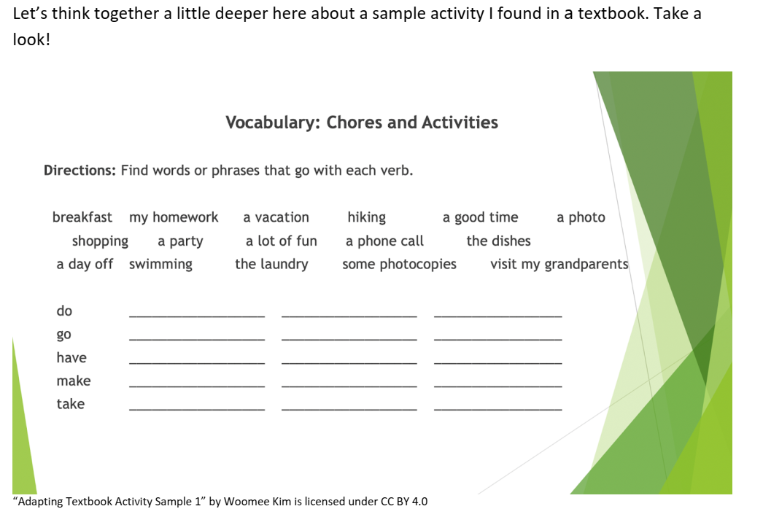  Is the activity interactive enough?  Is the text and content in the activity a bit difficult or not challenging enough?  Will this textbook activity motivate your students to engage in communication in English?  Video 2- Jigsaw activity about 3 tips for adapting teaching materials.  Group work of 3 participants in each one. Each participant reads and retells their partners about the tip they have read.  Based on the PPT (https://americanenglish.state.gov/files/ae/resource_files/webinar_15.2_-_slides_for_ae.pdf) participants will do some activities adapted to different types of learners:  1)Auditory- Dictoglossus  Learner Preferences  Auditory  Dictoglossus  1. Objectves  2. Pair students  3. Get ready to take notes  4. Read text normal speed  5. Read text again  6. Students work in small groups  7. Students read to each other  8. Teacher shows text  Dictoglossus  This morning after I made my bed, I heard my son make a phone call. He was talking with his friend. I was busy doing the dishes in the kitchen. He then told me he and his friends wanted to take a vacation to New York.I said,“No way! At the most, you and your friends can have a party at our house and go bowling.”  - Adapting Information Gap Activity with the help of 4 Window Tables  First, participants work in pairs to know each other about their free time activities.. Then , the teacher reads the activities to all the participants and they should go to one of the window tables, in this way we can see good communication among participants..  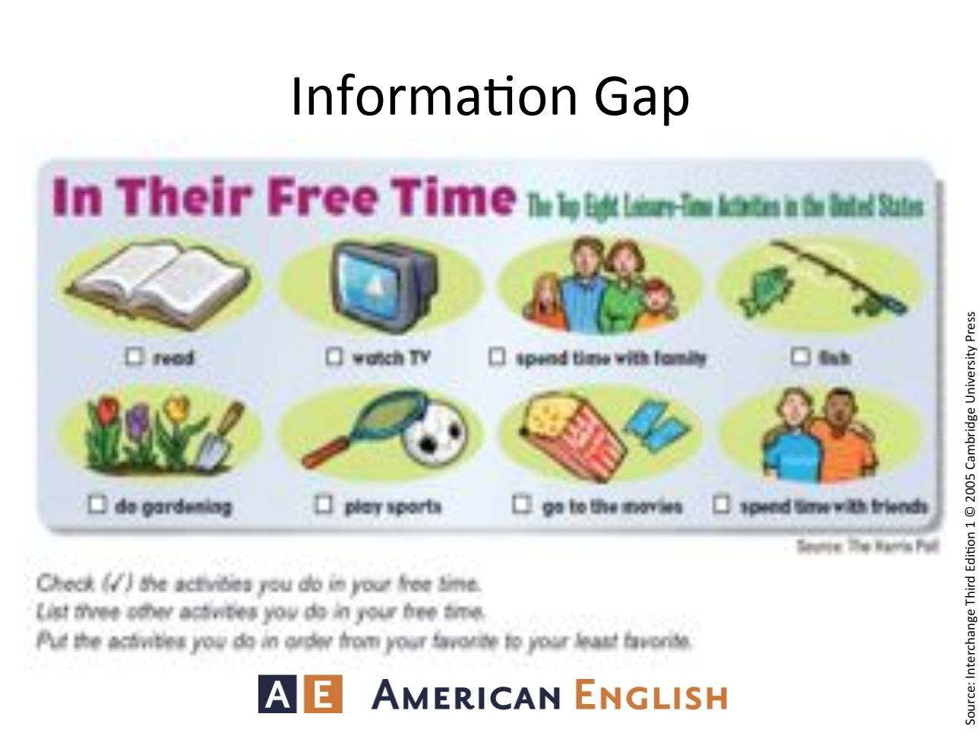  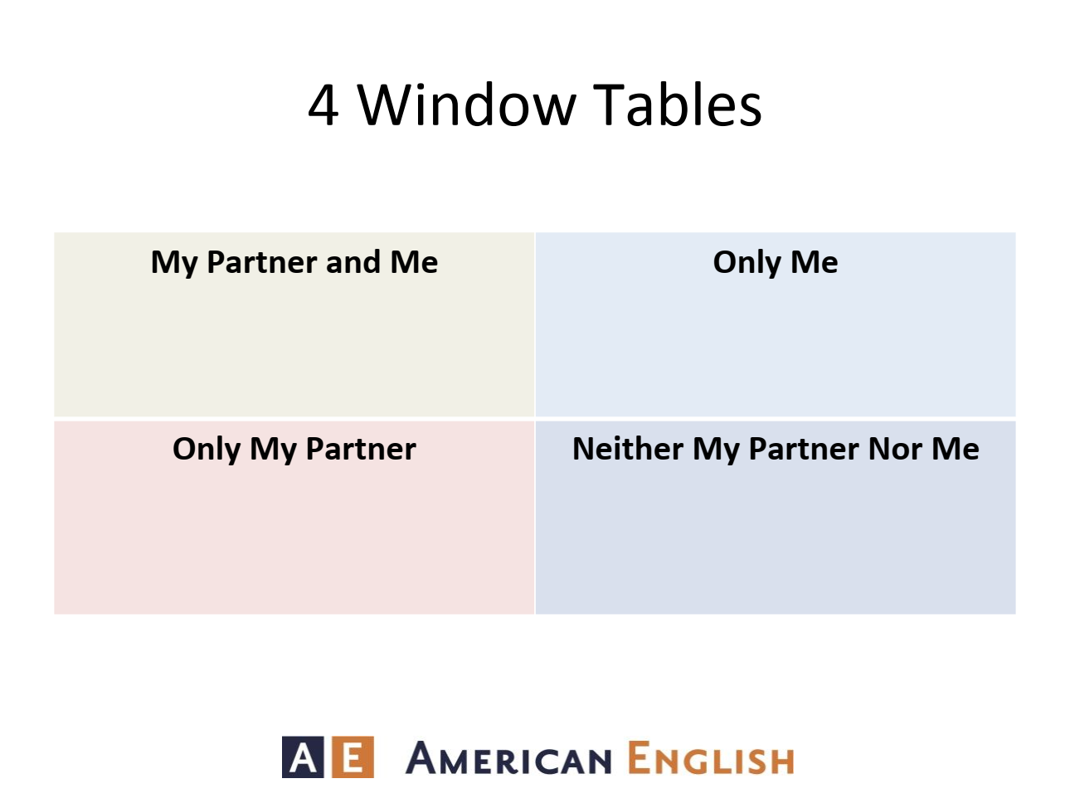 |  | 60 minutes
6. Elicit performance (practice) | Create an adapted textbook lesson/activity. Choose a lesson (or a part of a lesson) that you would like to adapt from your textbook. Describe your learner characteristics and teaching context. Which lesson/activity would you adapt and why? Present your newly adapted lesson/activity. Suggestions for activity adaptation:  - Make it into a role play  - Make it into a pair/group work  - Make it into a team quiz  - Simplify the language  - Replace with a jigsaw reading  - Use an information gap activity  - Gallery walk, reflect, and comment  - What else? What has worked for you in the past? |  | 45 minutes
7. Provide feedback | Look through your colleagues' lessons/activities. Find at least one or two new lessons/activities which you would apply in your next lesson and why. |  | 15 minutes
8. Assess performance | Using “Thumbs up, Thumbs down” respond card to check their comprehension about Extending Textbook Activities. | 15 minutes
9. Enhance retention and transfer | Before participants leave the workshops, ask them to complete the following sentence on stickers and stick them on the board to share with participants:  Extending Textbook Activities is important because … . | 10 minutes

