***LESSON PLAN –Orientation and Principles 1 and 2***

**Workshop Training Plan**

**Workshop Title:** Introduction and Principles 1 and 2

**Workshop Description:** This interactive workshop will introduce the course and give a start to the training and it will also present principles one and two with various activities to promote meaningful interaction in a classroom. Also, trainees will learn describe the importance of the principles one and two in a language classroom, how to examine and use a variety of effective activities that promote meaningful interaction in a classroom. They will also think about the role of the reflection in order to boost classroom practice and teacher development.

Time limit is: 4 hours

Objective: To get to know each other and break the ice in the classroom environment.

Warm up activity: To get to know each other and break the ice in the classroom environment. The trainer introduces the activity “Draw your favourite animal”. Every participant will be given a sheet of paper and they will write on it their names and draw their favourite animal. Then they stand in two rows (Fluency circle activity) and talk to the person standing opposite by introducing the name and why she/he drew that exact animal, support the conversation with definite reasons about favourite animal.

Introduction and course expectations. Introducing the content and structure and purpose of the training.

The teacher first introduces the overall course topic and then asks teachers to fill in the KWL chart. The teacher can prompt trainees what they know about Principles of teaching and TETE (teaching English through English).



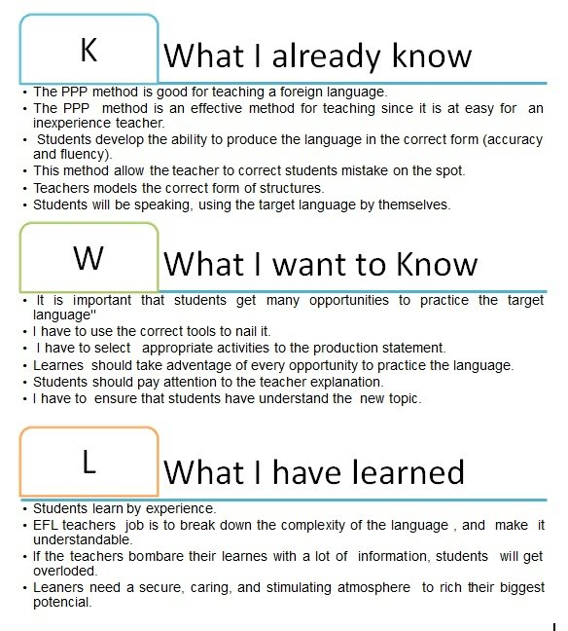

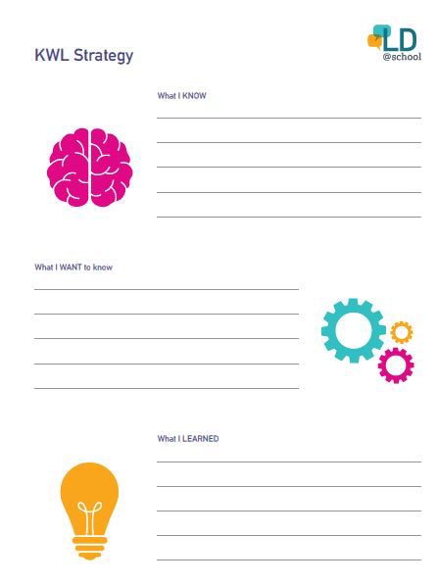

**Activity Balloon game “Who am I?”**

Balloon Game: Have everyone put one piece of information about them in a balloon, this information will be about themselves something interesting or traits of a character that makes this person be proud, or any hobby or strange thing about themselves. Then blow up the balloon and they will all mingle and share with this piece of information with others. They hold their balloons and share with the peers. They do not write their names on it. Or they can write their names on the other side of the balloon. Second round. Now they throw the balloon in the middle of the circle of participants. Then one by one, pop the balloons and guess to whom that piece of information belongs. It will break the ice and also be fun to know more about each other and built community learning environment.

**Activity “Story of my name”**

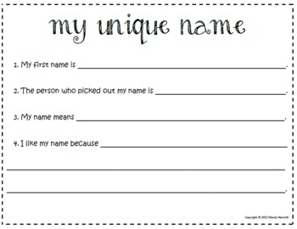 

In this activity, the participants are invited to share the story of their own name, its history and its meaning. The students learn more about each other, they learn to value each other’s background and they reflect on the connection between name, identity and cultural background.

Teachers can ask their students to inquire information about their name from their parents and to answer the following questions (might also be done as a homework):

* Who chose your name and why?
* Does it have a meaning?
* Was it always like this or has it changed?
* Do people sometimes pronounce or write your name in a wrong way?
* Do you like your name?
* How would you like to be called?
* How do your relatives and friends call you?
* Is there a different way of writing/pronouncing your name in another language?
* In which language version do you like your name most?
* Is there a story connected to your name?

Then the class will come together in a circle in class and the teacher invites the students to share the stories of their names. For this activity a flipchart or a board with the questions should be prepared. Nobody should be forced to answer all questions.

If you have time left, you can invite every participant to write his/her name on a paper and next to each letter of the name something typical for him/her, starting with the corresponding letter. It could be a characteristic, hobby, a person etc. Then everyone presents his/her ideas to the rest of the group.

Reflection:

* What did you notice about yourself as you participated in this activity?
* Where do our names come from? Did we see any common themes?
* If you’ve had the chance to name (or help someone to name) a new sibling, a pet, a doll, etc. what informed the choice you made?
* What do names tell us? Are they important? Why or why not?

Introducing principle 1. PowerPoint presentation

[Agenda and principles 1 and 2](https://docs.google.com/presentation/d/1RRSL_3yuNQiF0zDZBhHn_BDMPyRMN8VX/edit?usp=sharing&ouid=100951505374869245750&rtpof=true&sd=true) (from slide 16) /[Agenda day 1](https://docs.google.com/presentation/d/11eZLcFDYTIrGaliOUk5_jIjkJ9D5OyW7/copy#slide=id.gea936a2ac3_1_7)

Participants will be able to

* identify the 6 Principles for Exemplary Teaching of English Learners;
* discuss how we teach English
* describe the characteristics of specific age groups; and
* explore Principles 1, 2

Activity Stand up/Sit down

1. Listen to and/or read each statement. If it is true for you, stand up. If it is not true for you, sit down.
2. Look around so you can learn new information about your colleagues.
3. EXTENSION: Ask follow-up questions to people near you.

***PRINCIPLE 1: Know Your Learners (on the slides 50-51)***

***Activity Think-Pair-Share.***

What kinds of information can you collect? Elicit answers from trainees. Ask “Why do you think so?” Share in pairs your ideas.

* prior knowledge
* talents
* interests
* life experiences
* influences
* characteristics of specific age groups

Slide 52

Ask trainees how important it is to know characteristics of specific age groups? What age groups do they teach? What do they know about? They think and share in their groups. Then the trainer shows the slide and summarizes the answers.

***Characteristics of Children in Different Age Groups***

Physical – body

Cognitive – brain

Social-emotional – experiences, expressions, and emotions

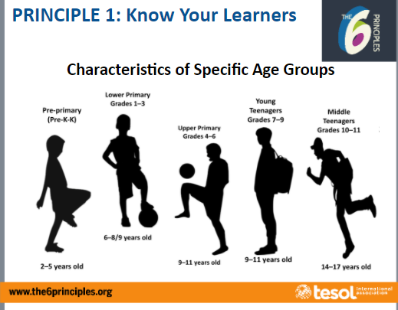

**Jigsaw activity.**

* 1. Count off 1, 2, 3, 4, 5 in your table groups. Remember your number for your Numbered Heads Together group.
  2. Go to your Numbered Heads Together group. If your group is too large, you can divide into smaller sub-groups.
  3. Read, discuss, and clarify meaning for the physical, cognitive, and social-emotional characteristics of your assigned group for 15

**Jigsaw Reading – MODELING**

*Directions*

1. Go to your Numbered Heads Together group. If your group is too large, you can divide into smaller sub-groups.

2. Read, discuss, and clarify meaning for the physical, cognitive, and social emotional characteristics of your assigned group for 15 minutes.

3. After 15 minutes, return to your table-group as the “expert” of your assigned age group. As the expert, you will summarize the characteristics of your age group while your table-group mates take notes. Be ready to answer and clarify meaning for them.

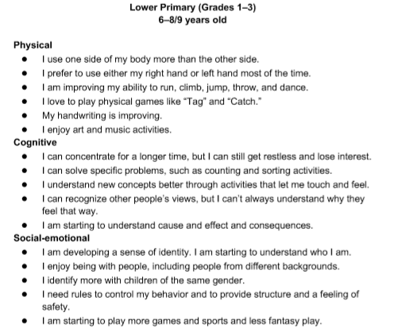

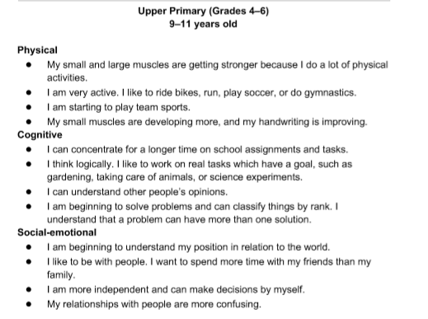

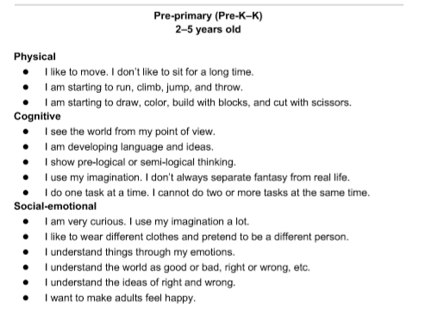

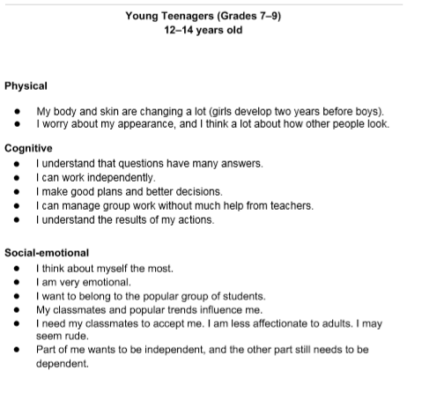

**DIRECTIONS –Jigsaw Note-Taking**

1. Take turns telling your group about your assigned age group.
2. Take notes about each age group. (Handout pdf document)

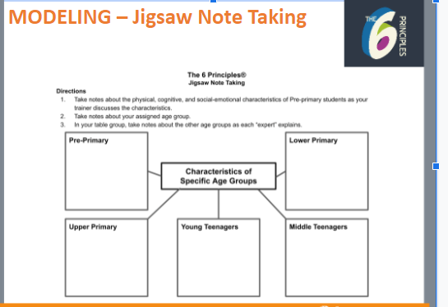

**ACTIVITY -Turn and Talk / Activity Tracker**

* Jigsaw Reading and Note Taking

The trainer introduces activity tracker and lists its importance of keeping track of all new learnt materials. Then trainees record on their handout the activity they have done and include it to their activity tracker.

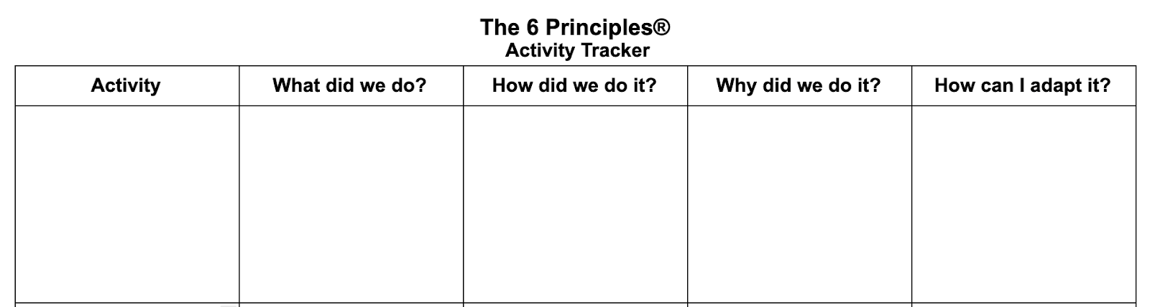

**ACTIVITY “Thumbs Up / Thumbs Down”**

1. The 6 Principles come from three years of research.
2. We can learn about characteristics of children at different age groups by looking at their physical, cognitive, and social-emotional stages.
3. A jigsaw activity is a good way for students to help each other build comprehension in a small group.

Extension. Every group creates three statements about the characteristics of the specific age groups and about principle 1 for Thumbs up/down activity. It means some of the statements should be true some of them false. Then in turns all the groups share and count their right responses to see which group got most correct answers.

**Activity “Find someone who”**

1. Read the statement in each box.
2. When I give you a signal, walk around the room for five minutes. Ask other people questions to see if they fit one of the statements below (e.g., “Have you ever traveled by train?”).
3. Write their name in the appropriate box.
4. Sit down when you finish or when I give you a signal.

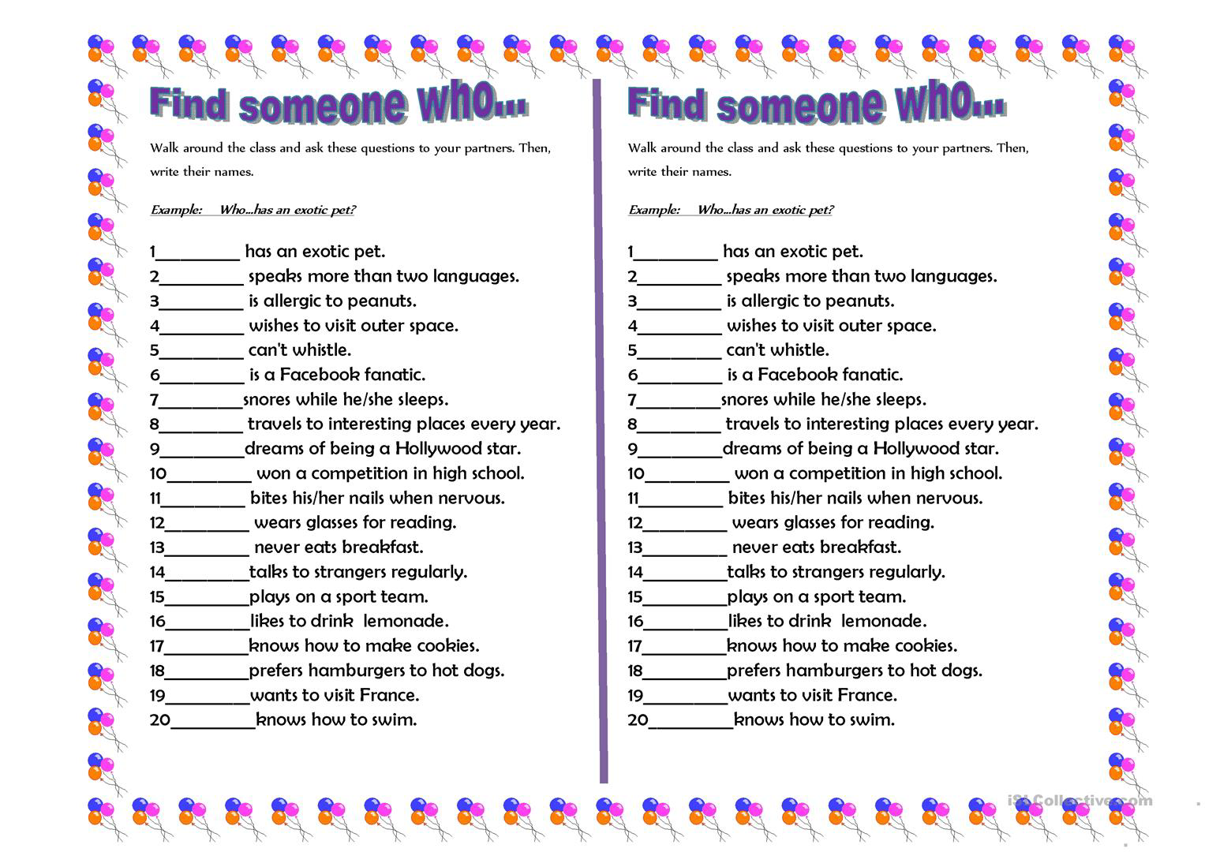

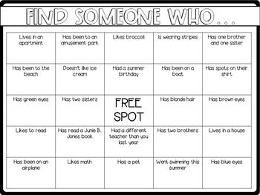

**Activity “Share and Care”.** ***Coffee Time.***

First trainees will be given 2 minutes to think of their main 3 goals on professional development plan. They make notes on stickers of different colors and stick them on the wall where we will have a poster with the title Tree of Goals. After they have coffee time and mingle and share their notes or goals with their peers and discuss. They can also approach the wall with poster and read and even leave their comment or ask questions from each other’s.

***PRINCIPLE 2. Create Conditions for Language Learning (Slide 88)***

**Activity – Personal Inventory**

1. Read each statement.
2. Rate yourself with the following criteria:
   * A – always or almost always
   * S – sometimes
   * N – never or almost never
3. Put a star (★) next to the three statements you most want to improve on.

Trainees look at the handout and fill in as instructed. Then whole class discussion and sharing.

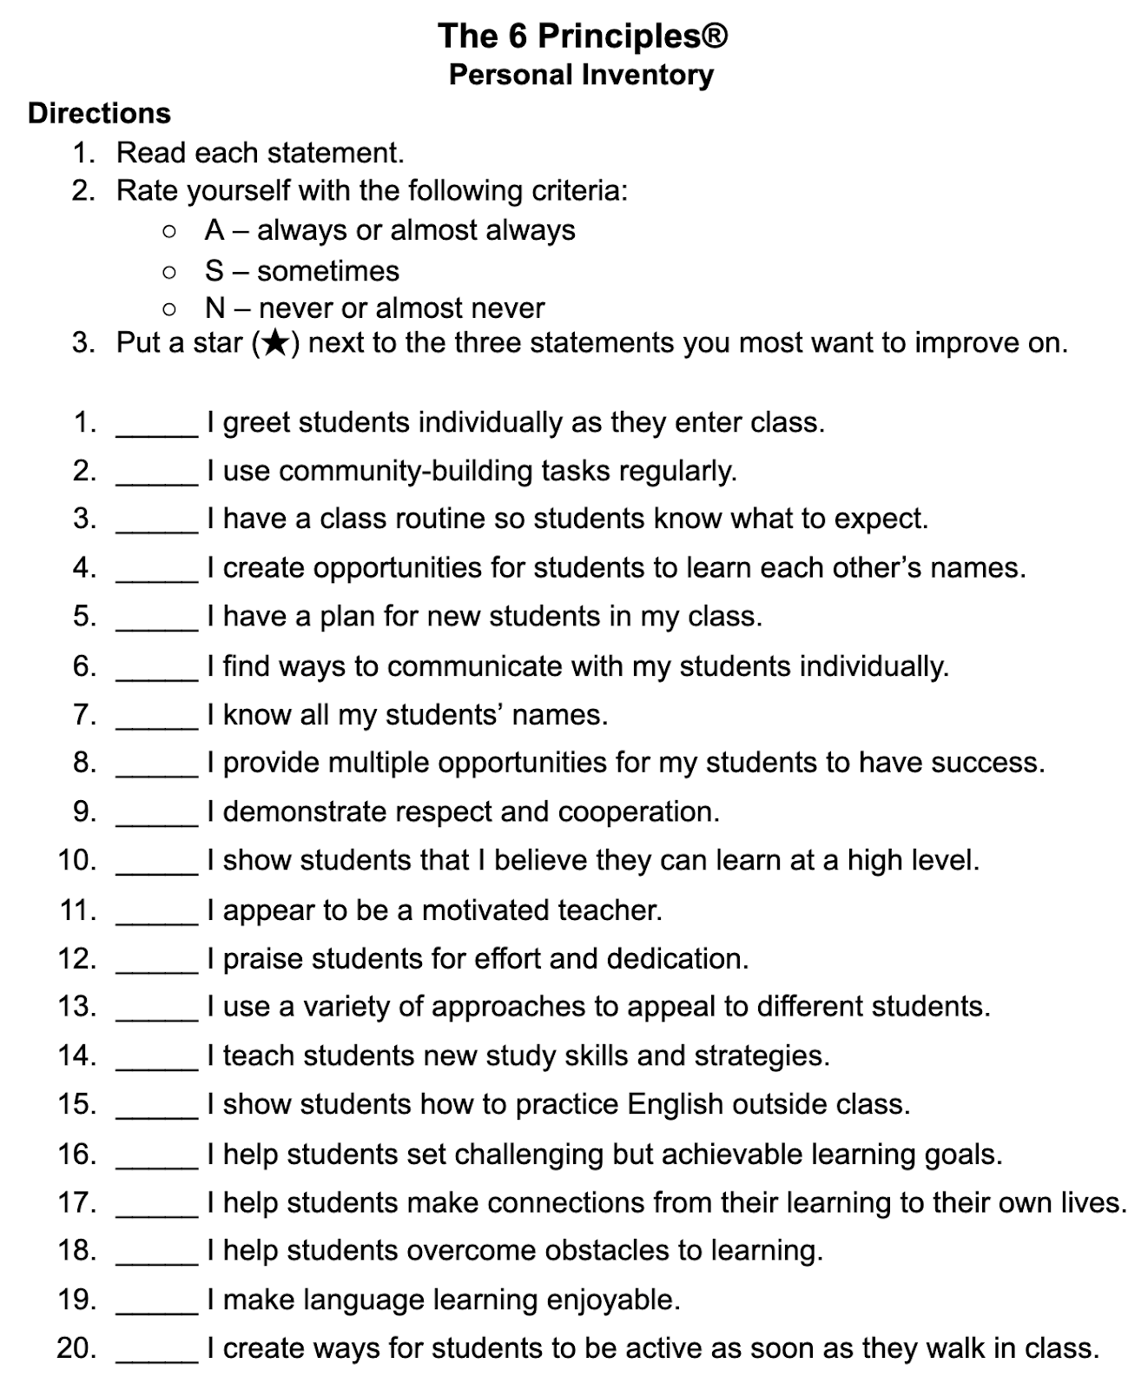

**Activity – Think-Pair-Share.**

1. Think about the question that you hear and/or read.
2. Pair with a partner, and discuss your answers.
3. Share in a larger group.

***Question:*** What are some activities that we have done today that could motivate students in my classroom?

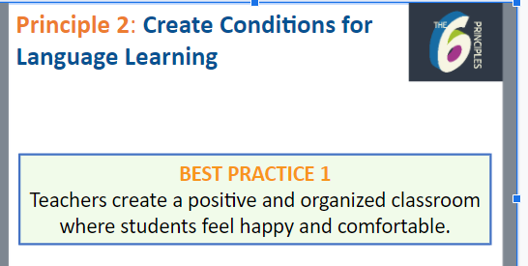

**Extension. Think-Pair-Share**

What are some ways you can create a positive and organized classroom where students feel happy and comfortable? Whole class share and summary.

Trainees rate the statements in the personal inventory and share some responses with the class.

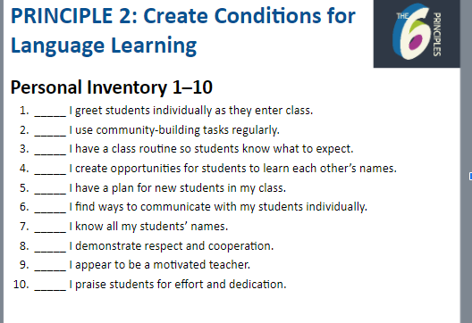

The trainer establishes the statement Best practice 2.

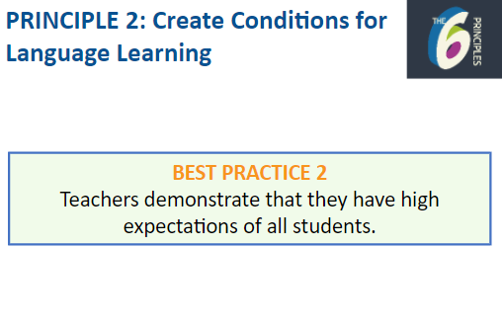

**Activity Think-Pair-Share**

* How do you demonstrate that you have high expectations of all students?

***Personal Inventory 11–15***

11. _____ I provide multiple opportunities for my students to have success.

12. _____ I show students that I believe they can learn at a high level.

13. _____ I teach students new study skills and strategies.

14. _____ I help students set challenging but achievable learning goals.

15. _____ I help students overcome obstacles to learning.

**ACTIVITY: Turn and Talk / Activity Tracker: Think-Pair-Share**



**Reflection**. <https://youtu.be/UaM8SgjnUVc>

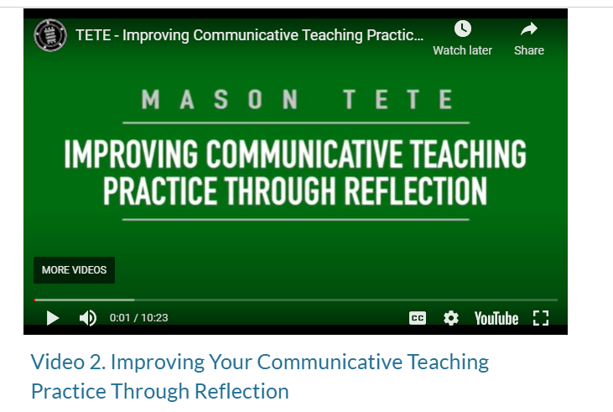

The whole class will watch video from TETE course about teaching and reflection. Discuss and share about reflection and its role. The trainer can ask trainees to google and come up with one quote about reflection and explain why he/she ahs chosen this particular quote. Whole class share.

***Activity Exit Ticket/ PQP Feedback.***

The whole class will write about what they have learnt or what was new for them, or if they have still questions about the content of today’s session.

***Technology Minute.***

WE all know that it is very important to better exploit technology and use it to our benefit in our classrooms. Today I want to share with teachers padlet tool and we will try to use it for reflection “What is one thing you learnt from today’s session/lesson? It is anonymous so teachers will not feel shy or stressed and feel free to share their true thoughts about their learning. At the end of the lessons we will all clap for our today’s hard work and express gratitude!!!

